Fulbright Hays- Ethiopia: Indigenous Wisdom And Culture
Everyday Objects in Ethiopia

Coffee Pots:
The Communal Practice of Creating a Communal Object
By: Amber Noelle Niedomys

Abstract:

Grades: 4-8th Grade (Adaptations and approaches can be modified to reflect desired age group’s experience levels)

Focus: The students will learn about the process of creating pinch pots. They will learn about the communal aspects of the Ethiopian potter’s community. The students will learn and engage in the process of making a pinch pot vessel as a whole class. This will be approximately four 44 minutes class periods. It is important for students to gain insight into how objects are handmade, what happens in the spaces that objects are being made, and what that represents about Ethiopian community.
Lesson Plans:
- Questions for Creativity: Object Exploration
- Making Communal Objects a Communal Activity
- Pinch Pot Studio Lesson

National Art Standards:
Anchor Standard 1: Generate and conceptualize artistic ideas and work.
VA:Cr1.2.8a Collaboratively shape an artistic investigation of an aspect of present day life using a contemporary practice of art and design.
Anchor Standard 11: Relate artistic ideas and works with societal, cultural, and historical context to deepen understanding
VA:Cn11.1.8a Distinguish different ways art is used to represent, establish, reinforce, and reflect group identity.
Essential Questions:
How do objects, places, and design shape lives and communities? How does art help us understand the lives of people from different times, places, and cultures? How does art preserve aspects of life?
Enduring Understanding: People create and interact with objects, places, and design that define, shape, enhance, and empower their lives. People develop ideas and understandings of society, culture, and history through their interactions with and analysis of art.
Lesson procedure:

Questions for Creativity: Object Exploration:
- Present the students with a Ethiopian coffee pot, do not explain anything about the object. (If you do not have access to one check resource below on how to gain access to one.) Allow students to examine pot with all of their senses. Be aware that these coffee pots are very fragile. Consider a one hand touch practice in which the object stays on the ‘sharing table’.
- In small groups, 3-5 students, ask students to discuss their first response to experiencing the object in terms of their senses. What does the object look, feel, smell, taste, and sound like. Building off of their responses ask what the object is, how they think the object is made, who made it, why was it made, and where & when the object is made.
  - The Visible Thinking Routine: Explanation Game can be helpful in organizing student responses. Students can respond in the format of identifying something interesting about an object "I notice that..." And then following that observation with the question: "Why is it that way?" or "Why is it made that way?"
- Once discussion of the presumed origins of the coffee pot has run its course, show video of traditional Ethiopian Coffee Ceremony. Describe what the function of the coffee pot is and how it is used in society. Discuss what aspects the students assumed correctly and incorrectly about the coffee pot.
Making Communal Objects a Communal Activity:
- Start class with the ETHIOPIAN EXPEDITION VIDEO. Point out the section with the family of potters creating coffee pots.
  - Points to note with students from video:
    - All of the women making coffee pots are family. They all learned their skill from their common grandmother. This is a skill passed down from mother to daughter, typically.
    - This is a community/family activity. They make the pieces together, with each person focusing on their own particular step of the process.
    - The potters make the process look easy, yet it should be noted that they are working with low quality materials but with a high level of skill and craftsmanship.
    - The fun of working together as a family- they are joyous with creating music and dance while making their pots.
  - The desired outcome of this video and discussion is to have students understand that creating and making can be a fun, energetic, and communal activity. For the studio portion of this unit, I will encourage a positive communal environment by requesting that students work in pairs, allowing music to be played, and flexible studio classroom seating.
Pinch Pot Studio Lesson
- Important things to remember:
    - Have the demo ready BEFORE start of lesson so that it transitions smoothly.
      - Prepare pile of pre-wedged clay for students following demo
    - Explain the steps of making a pinch pot while doing the demonstration. Be sure to point out main building points and criteria:
      - Half inch and even thickness walls
      - No fingerprints, dents, bumps, or cracks- if they appear, demo how to fix
      - LIGHT pinching and continuously moving in a circle to make a circular pot.
- After explaining and minimally demonstrating how to create a pinch pot, have the students sit in a whole class circle. Emphasize that in Ethiopian culture making is a communal activity and they make artwork, like coffee pots, together- and this is what we will do as a class- i.e. make a pinch pot as a class.
  - Start with a soft ball sized wedged clay ball. Start the pinch pot with a deep hole- then instructed the students to each ‘add a pinch’ to the wall and pass it to the next person. By the time the pinch pot makes it around a class it will begin to form a pinch pot that was made by everyone. If you feel that the pinch pot could use another ‘trip of pinching around the circle’, do so- just use your best judgement. The idea is to allow all students to understand and participate in the process of creating a pinch pot- as well as being introduced to the idea that creating art is a communal activity.

Additional Resources:
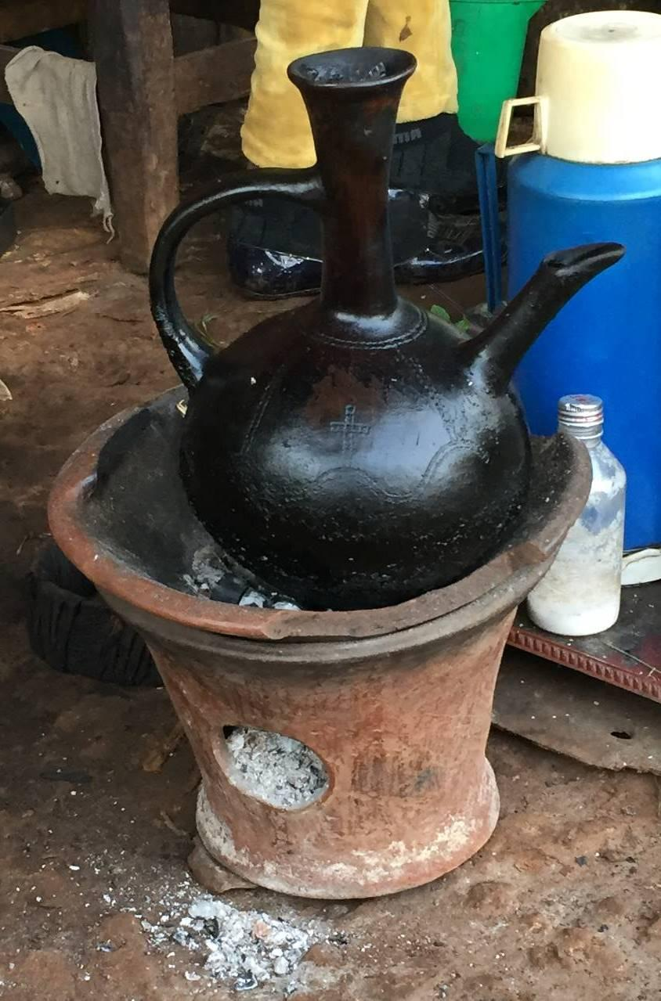
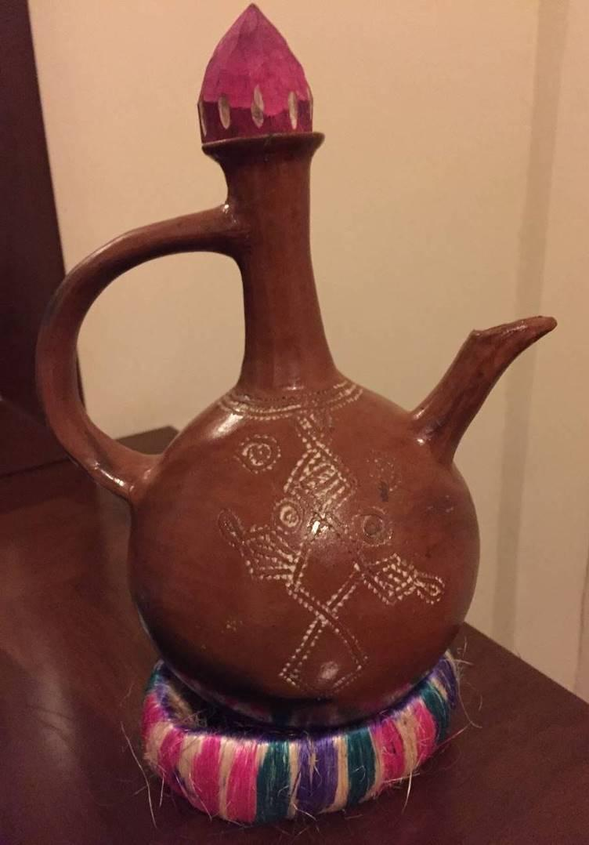
Pedagogical Elements (cards, manipulatives, games) –The majority of objects shown in the pictures are housed at the University of Pittsburgh African Studies Department. If you are interested in obtaining a box of these objects for your lesson, please contact:
African Studies Program
University Center for International STudies
AfricanStudies@pitt.edu
4138 Wesley W. Posvar Hall
Pittsburgh, Pennsylvania 15260
Phone: 412-648-1802

