Over the last two academic years, there have been students in our classrooms from over 40 different countries. Because we do not have large numbers of international students, it is sometimes easy to overlook their presence on campus. On October 6, faculty members from the University Center for International Studies at Pitt will provide unique insight into the life experiences of international students. They will discuss what is going on in different regions culturally, politically, and economically, explain how those factors impact students’ expectations, and provide the perspective of education professionals, your counterparts, from different countries. Please come prepared to explore higher education from an international perspective, to discuss how international students’ choice to study here enriches campus life and to share ideas about how we can best serve them.

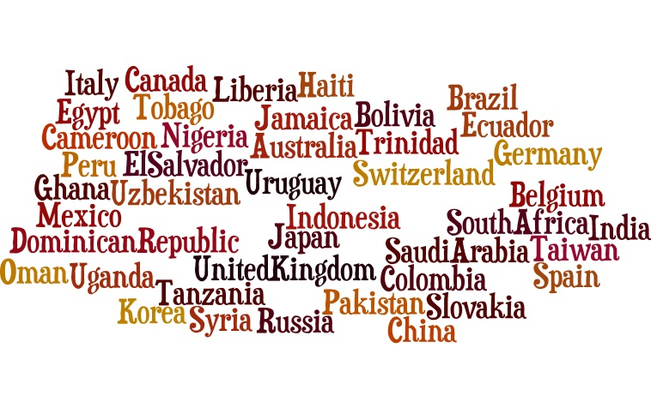

Westmoreland County Community College

Faculty Development

October 6, 2015

FHY Amphitheater

1. 8:00 a.m. – 9:00 a.m. Coffee and Refreshments – South Entrance Outside of Amphitheater
2. 9:00 a.m. – 9:15 a.m. Welcome and Greeting
3. 9:15 a.m. – 10:15 a.m. Presenter: W. James Jacob and Q & A / Discussion
4. 10:15 a.m. – 10:30 a.m. Break
5. 10:30 a.m. – 11:30 a.m. Presenter: Jorge Enrique Delgado, and Q & A / Discussion
6. 11:30 a.m. – 12:00 p.m. Smaller Groups Breakout Session
7. 12:00 p.m. – 1:00 p.m. Lunch Break
8. 1:00 p.m. – 2:00 p.m. Presenter: Maureen Porter and Q & A / Discussion
9. 2:00 p.m. – 2:15 p.m. Wrap-Up – Participants Complete Pitt Survey

**Presenter: W. James Jacob**

**Topic:** “Dragons, Tigers, and Turtles in International Contexts: The Cultural Background and Rising Role Chinese Students Play in U.S. Higher Education”

**Dr. W. James Jacob** is an Associate Professor of International and Higher Education in the School of Education at the University of Pittsburgh. Since 2007, Dr. Jacob has served as the Director of the Institute for International Studies in Education at the University of Pittsburgh. Dr. Jacob has worked with a number of private, public, bi-lateral, and multi-lateral organizations in his research endeavors, including Asian Development Bank, East-West Center, UNAIDS, UNDP, UNESCO, UNICEF, The World Bank, USAID, ProLiteracy Worldwide, South Pacific Forum, UNITUS, and many government ministries of education and health. His teaching interests and experience are in the areas of higher education management, strategic planning, human resource management, policy analysis, program evaluation, international development, research ethics, and organizational leadership and strategy. He has written extensively on comparative, international, and development education topics with an emphasis on higher education.

Dr. Jacob holds master’s degrees in Organizational Behavior (Marriott School of Management) and International Development (Kennedy Center for International Studies) from Brigham Young University and a PhD in Education from the University of California, Los Angeles.

**Co-Presenters:**

**Weiyan Xiong**, PhD Student, Higher Education Management Program, Department of Administrative and Policy Studies, School of Education, University of Pittsburgh

**Xi Wang**, PhD Student, Higher Education Management Program, Department of Administrative and Policy Studies, School of Education, University of Pittsburgh

**Presenter: Jorge Enrique Delgado**

**Topic:** “Education in Spanish- and Portuguese-Speaking Latin America: Students in U.S. Colleges and Universities”

**Jorge Enrique Delgado** holds a Bachelor’s in Dentistry, a Master’s in Education-Curriculum, and a PhD in Administrative and Policy Studies in Education (Social and Comparative Analysis in Education). Currently, Dr. Delgado works for the Journey of Hope program at Holy Family Institute with Central American unaccompanied children. He also teaches courses on “Latin American Social and Public Policy,” “Latin America & the Caribbean,” and “Social Foundations of Education” at the University of Pittsburgh. Dr. Delgado’s scholarly work focuses on the development of research in universities, particularly the communication of research through the publication of scholarly/research journals in Latin American universities and worldwide. His research covers topics such as knowledge-based economies and societies; higher education systems; science, technology, and innovation policy; institutional policy; faculty development; and open access and other publication trends. Dr. Delgado is currently the Co-Chairperson of the Higher Education SIG of the Comparative and International Education Society and Council member of the Education and Education Policy Section of the Latin American Studies Association. Dr. Delgado also publishes an online scientific journal with the Pontificia Universidad Javeriana in Bogotá, Colombia: Universitas Odontologica. Recently, Dr. Delgado published an edited book titled *Private Universities in Latin America: Research and Innovation in the Knowledge Economy*.

**Presenter: Maureen Porter**

**Topic:** “European Student Mobility: Understanding Trends, Systems, and Culture”

**Maureen Porter** is an Associate Professor in the School of Education’s Administrative and Policy Studies Department at the University of Pittsburgh. Her concentration is within the social and comparative analysis degree program. Porter’s current research projects focus on: place-based education; diversity, especially gender, and STE(A)M; metaphors and constructions of STE(A)M; and mapping educational spaces, policies, and paradigms. She is currently involved in leading study tours for educators and policymakers in Germany. She graduated with her PhD in Education and her MA in Anthropology, both from Stanford University. Her ongoing research interests include:

* Intercultural and international service-learning and study abroad
* Experiential and environmental education
* Civic engagement across the life span, including engaged scholarship at universities
* Qualitative research methods and epistemologies
* Arts-based inquiry and modes of representation in research
* Folk tales and fairy tales as transgressions and imaginations of gender and culture

**Co-Presenter: Rachel Robinson**

**Rachel Robinson** is a graduate of the University of Pittsburgh’s School of Education. She earned a Master’s of Education in Social and Comparative Analysis with a specification in International Education and Higher Education Management. Rachel also received a Global Studies Certificate with a focus on Western Europe. Prior to her time at Pitt, Rachel completed a Fulbright English Teaching Assistantship in Germany, where she worked with high school-aged students. Her professional experience in international education includes work in ESL and study abroad. In addition to living in Germany, Rachel also studied in Rome and completed volunteer work in Brazil.