**MOBILIZING PEOPLE, STUDENTS, AND IDEAS:**

**SOCIAL MOVEMENTS ACROSS THE GLOBE AND IN THE UNDERGRADUATE CURRICULUM**

**Friday, April 10, 2015**

**9:00 a.m. - 4:00 p.m.**

Learning Resources Center, Room 9110

Community College of Beaver County

A faculty and curriculum enrichment workshop sponsored by the international and area studies programs of the University Center for International Studies (UCIS) at the University of Pittsburgh. This is the first in a planned series of annual workshops aimed at internationalizing college campuses in the Western Pennsylvania region, with support from the Title VI National Resource Center program of the U.S. Department of Education. Participation by faculty from minority-serving institutions and community colleges is particularly encouraged.

**UNIVERSITY OF PITTSBURGH SPONSORS**

African Studies Center

Asian Studies Center

Center for Latin American Studies

Center for Russian and East European Studies

European Union Center of Excellence/European Studies Center

Global Studies Center

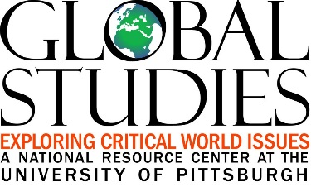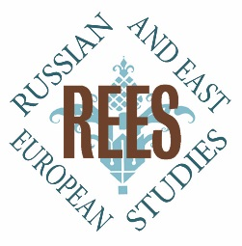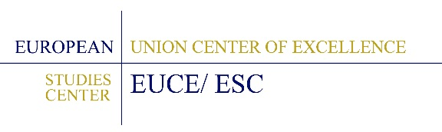

**SCHEDULE OF EVENTS**

9:00 a.m. Arrival and Breakfast

9:20 a.m. **Welcome and** **Overview**

John Gall, Ph.D., Dean of Liberal Arts and Sciences, Community College of Beaver County

Gina Peirce, Assistant Director, Center for Russian and East European Studies, University of Pittsburgh

9:30 a.m. “**The River and the Air Run Black: Teaching China’s Environment”**

James Cook, Ph.D.

Associate Director, Asian Studies Center

University of Pittsburgh

10:10 a.m. Q&A and Discussion

10:30 a.m. Break

10:40 a.m. **“Global Hip Hop: Multidisciplinary Approaches to Talking About Race in the Classroom”**

Adriana Helbig, Ph.D.

Associate Professor of Music University of Pittsburgh

11:20 a.m. Q&A and Discussion

11:40 a.m. **Breakout Session #1: “Challenges for Internationalizing the Campus and Curriculum”**

In small groups, all workshop participants will discuss issues of internationalizing the campus and curriculum. How can faculty and administrators infuse international content into courses in a broad range of disciplines and encourage students to pursue internationally oriented learning experiences (including extracurricular activities, study abroad, etc.) to build global competencies and increase their competitiveness in the workforce? What are some of the challenges involved in reaching particular groups such as minority students, first-generation college students, and non-traditional students returning to school?

12:10 p.m. Lunch

12:50 p.m. **“Social Movements and Cultural Resistance in Pre-and Post-Chavez Venezuela”**

Karen Goldman, Ph.D.

Assistant Director for External Relations, Development and Assessment, Center for Latin American Studies University of Pittsburgh

1:30 p.m. Q&A and Discussion

1:50 p.m. Break

2:00 p.m. **“Political Regimes Mobilizing People across the Globe in the Short Twentieth Century”**

  Diego Holstein, Ph.D.

Associate Professor of History

Associate Director, World History Center

University of Pittsburgh

2:40 p.m. Q&A and Discussion

3:00 p.m. **Breakout Session #2: “Solutions for Internationalizing the Campus and Curriculum”**

In small groups, all workshop participants will continue discussing issues of internationalizing the campus and curriculum. How could some of the challenges identified during the first breakout session be effectively addressed? What ideas have you gained from this workshop for infusing international content into your courses and/or other aspects of student life on your campus?

3:30 p.m. Sharing Out from Breakout Groups/Final Discussion

4:10 p.m. Evaluations

4:30 p.m. Adjournment

**SPEAKER BIOS**

**James Cook** is the Associate Director of the Asian Studies Center at the University of Pittsburgh. He earned his Ph.D. at the University of California, San Diego in 1998 in modern Chinese history. His areas of research include the Overseas Chinese diaspora, urban history, and environmental history. He lived and conducted research in China in the 1990s and is fluent in Mandarin. His most recent publications include *Visualizing Modern China: Image, History and Memory, 1750-Present* and “China’s New Sorrow: Water-Management Policies, Environmental Degradation, and Salar-Tibetan Minority Relations in Qinghai Province,” in the journal *Twentieth Century China*.

**Karen Goldman** is Assistant Director for External Relations, Development and Assessment at the Center for Latin American Studies and Research Associate in the Department of Hispanic Languages at the University of Pittsburgh. Dr. Goldman holds a Ph.D. in Spanish and Latin American Literature from Columbia University. She was previously on the faculty of Pitzer College in Claremont, California and Chatham University. Her scholarly and teaching interests lie in the fields of contemporary Latin American and Latino cultural studies. Recent publications focus on Spanish and Latin American cinema and representations of Latinos in U.S. popular culture, including “*Saludos Amigos* and *The Three Caballeros:* Representations of Latin America in Disney’s *“Good Neighbor”* Films” in *Diversity in Disney Films: Critical Essays on Race, Ethnicity, Gender, Sexuality and Disability,* and “Rural and Urban Brazil in Cinema Nôvo and Beyond: *Barren Lives* and *The Hour of the Star*” in *Representing the Rural: Space, Place and Identity in Films About the Land.*

**Adriana Helbig** is Associate Professor of Music and an affiliated faculty member in Cultural Studies, Women's Studies, Global Studies, and Russian & East European Studies at the University of Pittsburgh. A member of the graduate faculty, she teach courses on global hip-hop; world music; music, gender, and sexuality; music and technology; and cultural policy. Her articles on Romani (Gypsy) music; post-socialist cultural policy; music and piracy; music, race, and migration; and global hip-hop have appeared in edited collections and journals such as *The Yearbook for Traditional Music*, *Current Musicology*, and *Popular Music*. In her recently published ethnography *Hip Hop Ukraine: Music, Race, and African Migration* (Indiana University Press, 2014), she examines how localized forms of hip hop create social and political spaces where an interracial youth culture can speak to issues of human rights and racial equality among African students, African immigrants, and local populations in eastern Ukraine.

**Diego Holstein** is Associate Professor of History and Associate Director of the World History Center at the University of Pittsburgh. **He earned his** Ph.D. at the Hebrew University of Jerusalem in 2003. His fields of research are Medieval Spain and World History. In his first book, La Era Mozárabe(1085-1315), he analyzed the economic conflicts and cultural clashes as well the processes of integration and acculturation that followed the Castilian conquest of Toledo (1085). His second book, Thinking History Globally, organizes ways of thinking beyond national and regional boundaries into four strategies: comparing, connecting, conceptualizing, and contextualizing. This book defines, explains, and exemplifies twelve trans-boundary branches of history (comparative, relational, international, transnational, oceanic, global, world, and big histories, historical sociology, civilizational analysis, world-system approach, and history of globalization). He has thirty additional publications on Medieval Spain and World History and has taught or lectured on these subjects in North and Latin America, Europe, Israel, China, and Australia. He is currently working on globalization and hegemony in world history. ​