“Change and Adaptation in Eastern Europe”

Workshop Series in conjunction with “Bridging Cultures: Eastern Europe in the Curriculum”

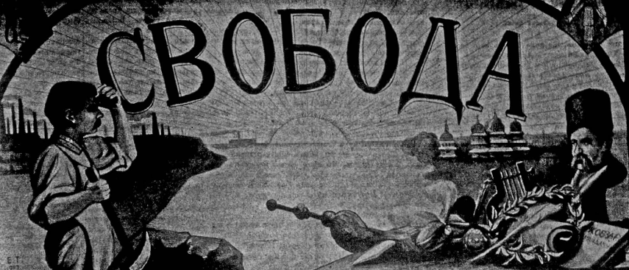

Spring 2015

LRC Room 9113, CCBC

6-9 PM Bi-weekly Thursdays

(1/8, 1/22, 2/5, 2/19, 3/5, 3/19, 4/2, 4/16)

Faculty Coordinators:

Joel Brady, PhD (jcb33@pitt.edu)

Ljiljana Duraskovic, PhD (ljiljana@pitt.edu)

Project Coordinators: Andrew Konitzer (Pitt Project Director), John Gall (CCBC Project Director), Gina Peirce (Pitt Project Coordinator), Julie Durbin (CCBC Project Coordinator)

**Workshop Series Description**

“Change and Adaptation in Eastern Europe” is a workshop series meeting bi-weekly during Spring 2015. It forms a major component of “Bridging Cultures: Eastern Europe in the Curriculum,” a collaborative project between Community College of Beaver County and the University of Pittsburgh’s Center for Russian and East European Studies, which is funded by a National Endowment for the Humanities grant and intended to foster internationalization of community college curricula through the integration of East European humanities topics. CCBC is an ideal venue for this series, given the East European immigrant familial background of many CCBC students.

**Workshop Series Learning Objectives**

By the end of this series, participants will be able to…

* Provide a broad overview of East European history and culture from the nineteenth century to the present.
* Identify and explain key themes in that history and culture, including imperialism, nationalism and nation building, interreligious relations, transatlantic migration, socialism and post-socialism, East-West relations, and others.
* Identify particular points of relevance of these themes for their own community college students, including those with East European immigrant familial backgrounds.
* Integrate select East European historical and cultural themes into their own community college curricula by developing a plan for an original course module that will incorporate content from the workshop series.

**Required Textbooks**

The following texts have been purchased for and will be distributed to workshop participants.

Drakulic, Slavenka. *How We Survived Communism and Even Laughed*. London: Harper Perennial, 1993.

Bodnar, John E. *The Transplanted: A History of Immigrants in Urban America*, Interdisciplinary Studies in History. Bloomington: Indiana University Press, 1985.

Chwin, Stefan. *Death in Danzig*. Translated by Philip Boehm. London: Vintage, 2006 [1995].

Wanner, C. *Burden of Dreams: History and Identity in Post-Soviet Ukraine*. University Park: Pennsylvania State University Press, 1998.

Bell, Thomas. *Out of this Furnace*, University of Pittsburgh Press, 1976 [1941].

Mazower, *The Balkans: A Short History.* Modern Library Chronicles, New York: Modern Library, 2002.

Ugresic, Dubravka. *Baba Yaga Laid an Egg*. Canongate Press, 2011.

Andric, Ivo. *The Bridge on the Drina*; translated by Lovett F. Edwards, 1977 [1961].

Johnson, Lonnie R. *Central Europe: Enemies, Neighbors, Friends*. Oxford, 2011.

Additional readings will be provided via the Blackboard site.

**Expectations for Participants**

Participants will be expected to…

*complete required readings beforeworkshop sessions

*participate in and contribute to workshop discussions

*meet once during the semester with a faculty coordinator to discuss integration of an East European theme into the workshop participant’s own curricula

*submit and present a plan for that integration at the final workshop session.

**Assignment: Designing an East European Course Module**

During the course of the workshop series, participants will begin initial planning to implement an East European theme as a module in one of their own courses. Practically, that will entail (a) one meeting (either in-person or via teleconference) with a faculty coordinator (Ljiljana or Joel) during the Spring semester for a preliminary discussion; (b) submission by 4/13 of a formal written preliminary plan for integration of an East European theme into a course module in their own courses; and (c) presentation of that preliminary plan in the final workshop session on 4/16. After the workshop series concludes, participants will hold at least one more meeting with their assigned faculty coordinator to finalize plans for integration. Faculty coordinators will be available for additional support and feedback as needed.

**Workshop Schedule**

Session 1 (January 8, 2015): Overview of project schedule, main themes and countries to be studied; pre-19th century history of the East European region.

*Readings:*

*Stoker, *Dracula* (selection provided in session)

Session 2 (January 22, 2015): History of East European region from 19th century to the present, with emphasis on the empires that impacted the history of the region (Austro-Hungarian, Ottoman, Russian/Soviet); the emergence of national identities and consciousness in the 19th century; the world wars and postwar communist period in the 20th century; and major political, economic, social and cultural developments in the post-communist period.

*Readings:*

*\*ENF*: 118-135, 141-151, 156-186, 220-225, 230-258

*Brubaker, *Nationalist Politics in a Transylvanian Town* (introduction) (BB)

*Cornis-Pope and Neibauer, “Towards a History of the Literary Cultures in East-Central Europe: Theoretical Reflections,” ACLS Occasional Paper, No. 52 (2002), 1-17. (BB)

*Wolff, *Inventing Eastern Europe* (selections) (BB)

*Optional*

Snyder, *Reconstruction of Nations* (selections) (BB)

Brady and Hajderpasac (BB)

Session 3 (February 5, 2015): East European immigrant experiences in the U.S., including comparative case studies of Jewish immigrant communities from the region; Slovak Catholic immigrant communities; and Rusyn communities with ties to both the Eastern Orthodox and Greek Byzantine religious traditions. Discussion of the shifting and/or loss of national, ethnic, cultural, and religious identities as a part of the immigrant experience.

*Readings:*

*Handlin, *The Uprooted* (selections). (BB)

*Bodnar, *The Transplanted*, xv-xxi, 9 (last sentence)-13 (1st paragraph), 18 (last paragraph) – 20 (1st paragraph), 21 (3rd par) – 22 (1st par), 38-56, 57-70, 83-84, 117-168, 184-189

*Bell, *Out of this Furnace* (selections).

*Wyman, *Round Trip to America*,Chapters 1 and 8. (BB)

*Kuropas, *The Ukrainian Americans* (selections)

*Optional:*

*Morawska, Ewa. “Immigrants, Transnationalism, and Ethnicization: A Comparison of This Great Wave and the Last.” Chapter 5 in Gerstle, Gary and John Mollenkopf, eds. *E Pluribus Unum? Contemporary and Historical Perspectives on Immigrant Political Incorporation*. New York: Russell Sage Foundation, 2001: (Selection: 175-193). (BB)

Kuropas (selections)

Session 4 (February 19, 2015): Histories, cultures and literature of the countries of the former Yugoslavia, including Serbia, Croatia and Bosnia, in the 19th and 20th centuries prior to the Balkan wars of the 1990s, gender in the Balkans.

*Readings:*

*Andric, *The Bridge on the Drina* (selections)

*Mazower, *The Balkans* (selections)

*Bakić-Hayden, Milica. “Nesting Orientalisms: The Case of Former Yugoslavia.” *Slavic Review*, Vol. 54, No. 4 (Winter 1995), pp. 917-931. (BB)

Session 5 (March 5, 2015): The post-Tito period in Serbia, Croatia and Bosnia, including the wars of the 1990s, the breakup of Yugoslavia and subsequent political, economic, social and cultural developments up to the present day.

*Readings:*

*Albahari, David. *Snow Man* (selections)

*Ugresic, Dubravka. *Baba Yaga Laid an Egg* (selections)

*Mazower, *The Balkans* (selections)

*\*ENF*, 297-304

*In-class Screenings*

Milic, *Jagoda in the Supermarket*

Zalica, *Fuse*

*Pretty Villages, Pretty Flame*

Session 6 (March 19, 2015): Historical, cultural and literary developments in Poland from the 19th century to the present day. Case study of an East Central European country that has adopted a “Western” political and economic system and joined “Western” institutions, such as NATO and the European Union, while maintaining a strong sense of its unique national and cultural identity.

*Readings:*

*Chwin, *Death in Danzig* (selections)

*Huelle, *Moving House. Stories* (selections)

*\*Enemies, Neighbors, Friends* 173-180, 200-202, 213-216

*Buzalka, *Nation and Religion: The Politics of Commemoration in South-East Poland,* 2008. (selections)

*Optional (pre-19th C)*

*\*ENF*, 44-50, 90-105

*Snyder, *The Reconstruction of Nations* (selections) (BB)

Session 7 (April 2, 2015): Historical, cultural and literary developments in Ukraine from the 19th century to the present day. Case study of an East European country with a rich, yet contested, national and cultural identity and political, economic and societal institutions that are continually influenced by strong neighbors to both the east (Russia) and west (the European Union).

*Readings:*

*Wanner, C. *Burden of Dreams: History and Identity in Post-Soviet Ukraine*

*Snyder, *The Reconstruction of Nations* (selections) (BB)

*Taras Shevchenko *Kobzar* (selections) (BB)

*In-class Screenings*

\**Evenings on a Farm Near Dikanka*

**\*\*\*Submit preliminary plan for integration of an East European theme into course module by 4/13.\*\*\***

Session 8 (April 16, 2015): Wrap-up and brief review of themes addressed throughout the workshop series; presentation of course module ideas by CCBC faculty participants and receipt of feedback and suggestions from Pitt workshop coordinators and other CCBC participants.

*Readings:*

*Drakulic, Slavenka. *How We Survived Communism and Even Laughed* (selections)

*Barnes, Jonathan, “St. Nicholas Church Tells a Modern Story,” *Pittsburgh Quarterly*, Spring 2008. (BB)

*Brett, Edward. “A Monument to Catholic Social Justice: The Maxo Vanka Murals of St. Nicholas Croatian Church, Pittsburgh, Pennsylvania.” *American Catholic Studies*, Volume 122, Number 1, Spring 2011, pp. 101-107. (BB)