**WORKING WITH INTERNATIONAL STUDENTS ON YOUR CAMPUS**

**Friday, February 12, 2016**

**9:00 a.m. - 4:00 p.m.**

Learning Resource Center, Room 9103

Community College of Beaver County

A faculty and staff enrichment workshop sponsored by the international and area studies programs of the University Center for International Studies (UCIS) at the University of Pittsburgh. This is the second in a series of annual workshops aimed at internationalizing college campuses in the Western Pennsylvania region, with support from the Title VI National Resource Center program of the U.S. Department of Education. Participation by faculty from minority-serving institutions and community colleges is particularly encouraged.

**UNIVERSITY OF PITTSBURGH SPONSORS**

African Studies Center

Asian Studies Center

Center for Latin American Studies

Center for Russian and East European Studies

European Union Center of Excellence/European Studies Center

Global Studies Center

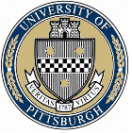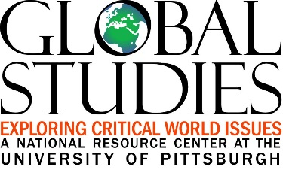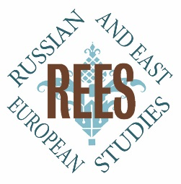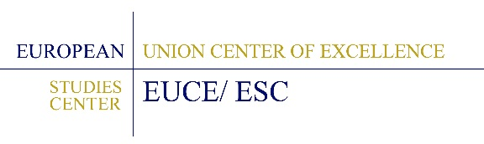

**SCHEDULE OF EVENTS**

9:00 a.m. Arrival & Breakfast

9:20 a.m. **Welcome and** **Overview**

Julie Durbin, UCIS Partnership Coordinator, Community College of Beaver County

Gina Peirce, Assistant Director, Center for Russian and East European Studies, University of Pittsburgh

9:30 a.m. **Keynote Address: “Not So Foreign: Why International Students Are Coming to American Campuses—and How They’re Changing Them”**

Karin Fischer, Senior Writer, *The Chronicle of Higher Education*

10:20 a.m. Break

10:30 a.m. **Panel Discussion: “International Student Admissions and Orientation”**

Lauren Panetti, Senior Assistant Director, Office of Admissions and Financial Aid, University of Pittsburgh

Sara Jones, Associate Director, Office of International Services, University of Pittsburgh

11:45 p.m. Lunch & Cultural Competence Activity

12:35 p.m. **Panel Discussion: “International Students’ Academic Experience”** Meiyi Song, Instructional Designer/Teaching and Learning Consultant, Center for Instructional Development and Distance Education, University of Pittsburgh

Rob Mucklo, Special Programs and Activities Supervisor, English Language Institute, University of Pittsburgh

1:50 p.m. Break

2:00 p.m. **Panel Discussion: “International Student Life and Advising”**

Renee Camerlengo, Assistant Dean of Student Affairs, Carnegie Mellon University

Shawntia Key, International Programming Coordinator and Advisor, Cross Cultural and Leadership Development, University of Pittsburgh

3:15 p.m. **Small Group Breakout Session**

In small groups facilitated by the panelists, all workshop participants will discuss questions, issues and/or challenges that they anticipate (or have already encountered) in working with international students in admissions, orientation, teaching, advising, student services, etc. How could these issues and challenges be addressed at your institution? What ideas have you gained from this workshop for supporting international students on your campus, while ensuring that their presence enriches the educational experience of all students at your school?

3:40 p.m. **Final Discussion and Survey Completion**

4:00 p.m. Adjournment

**KEYNOTE SPEAKER PROFILE**

Karin Fischer is a senior writer for *The Chronicle of Higher Education*, where she reports on the business of international education and the globalization of higher education. Among the issues she covers are competition for foreign students, activities by American colleges overseas, policies and programs that affect universities’ international efforts, and the internationalization of the college experience. She has written extensively about international student recruitment and the experience of foreign students in the U.S., including “A Freshman Year, Far from Home,” which followed Chinese students through their first year on an American campus, and “The Chinese Mother’s American Dream,” an examination of why parents bet big to send their children abroad. She also writes about the relationship between colleges and the economy.

Ms. Fischer previously worked for Kiplinger Washington Editors, MediaNews Group’s Washington bureau, the *Charleston Daily Mail*, and the *Daily Hampshire Gazette*. Her work has appeared in *The New York Times*, *The Washington Monthly*, and *George* magazine. In 2010, she was selected for the East-West Center’s Jefferson Fellowship program for reporting in Asia. She also is the recipient of Paul Miller and National Press Foundation fellowships and is part of reporting teams that have been honored by the Education Writers Association. A graduate of Smith College, she received the Poynter Institute News Reporting & Writing Fellowship for College Graduates, which recognizes outstanding young journalists.