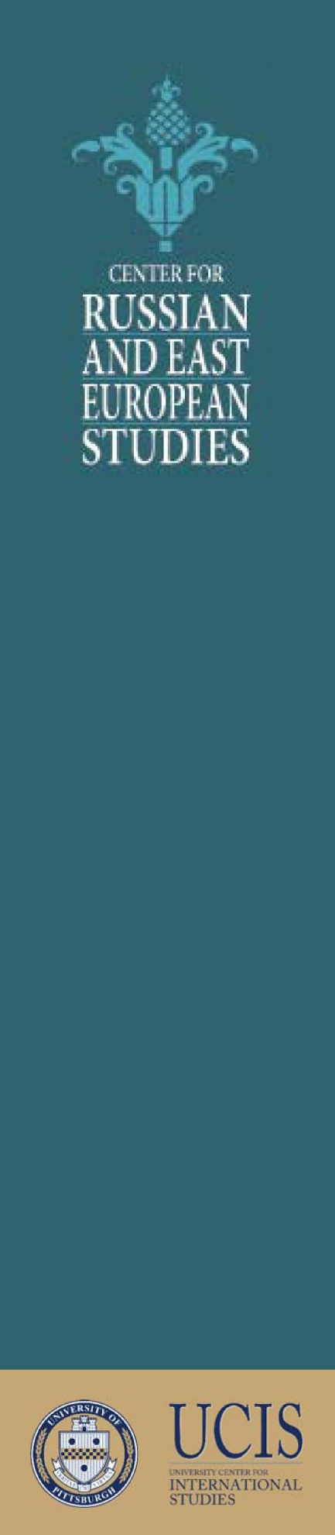 | Was He? Was He Not?  And Why It Should Matter: Chaikovsky’s Sexuality and Russia’s Politics  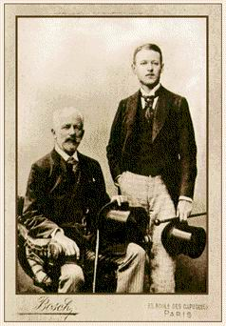  Anna Nisnevich, PhD  Assistant Professor  of Musicology  Department of Music  Wednesday, October 16  12:00pm  4217 Posvar Hall  In recent months, Chaikovsky has moved to the center of Russia's politics: while he continues to exemplify the country's rich cultural heritage, the staunch presence of this avowedly gay composer in the repertory has drawn much attention to the dubiousness of the government's latest anti-gay policies. In this lecture, as I reflect on the renewed Chaikovsky controversy in Russia, I will also trace the roots of the uneasy association between aesthetics and the composer's sexuality to the high Stalinist era.  Two antagonistic trajectories took off in the mid-1930s USSR: the normativization of Chaikovsky’s music as articulating some basic humanity and thus virtually universal; and the pathologizing of homosexuality as a sort of social illness only found in the unjust bourgeois society. A range of multi-media examples will demonstrate how Chaikovsky would come to be universalized in the Soviet and early post-Soviet imaginary. What we witness today, I suggest, is a product of that long and thorough process.

