Beyond Akcja “Wisła”:
The Recollections of Lemkos Who Experienced Ethnic Cleansing in Poland, 1944-1947
Presentation by Corinna Wengryn Caudill, MPIA

In the fall of 1944, the Soviet Union and the communist Polish Committee for National Liberation (PKWN) began a population-exchange campaign that mandated the relocation of Poland’s Ukrainian population, including the Lemkos, to the Soviet Union. What began under the guise of “voluntary” relocations soon escalated into terror and state-sponsored ethnic cleansing, fueling violent resistance from the rapidly expanding Ukrainian underground. From 2010-2013, independent researchers Corinna Wengryn Caudill and Richard Garbera Trojanowski collected oral history interviews with ethnic Lemkos who experienced the subsequent deportation campaigns. They interviewed research participants from North America, Ukraine, and Poland who were deported to Soviet Ukraine during 1944-1946, as well as Lemkos who were deported to Poland’s “Recovered Territories” during the 1947 “Akcja Wisła" operation.

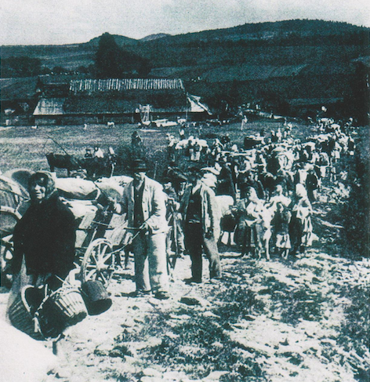
The first part of Ms. Caudill’s multimedia presentation, which will feature English-captioned film segments from some of the interviews, will focus on the experiences of Lemkos who were resettled to Soviet Ukraine between 1944-1946, and how the so-called “voluntary” resettlement program quickly evolved into a forced deportation campaign. The second part will focus on the 1947 resettlement operation known as “Akcja Wisła,” the final and most comprehensive campaign to deport the remainder of Poland’s Ukrainian population from their historic settlement territories. She will discuss: (1) the motivations and tactics used by the Polish government to resettle and disperse those who were deported; (2) the Lemkos’ experiences before, during, and after resettlement; and (3) the aftermath and impact of these events on the people who experienced them as well as common historical misconceptions about the nature of the resettlements.

Biographical Statement: Corinna Wengryn Caudill is a professional writer and editor specializing in nonfiction works, academic texts, and business writing. She holds an M.A. in Public and International Affairs and a B.A. in Political Science from University of Pittsburgh. Previously, she has worked as a researcher and analyst for the U.S. Government Accountability Office (GAO) in Washington, D.C., and has also worked as a consultant for several U.S. government agencies; including the National Institutes of Health (NIH), the Department of Defense (DoD), and the Department of Homeland Security (DHS). She is an ethnic Lemko with roots in Sanok County, Poland, and is an active member of the Organization for the Defense of Lemkivshchyna (OOL) based in Yonkers, NY.

