**CHINA’S 1911 REVOLUTION: How it Continues to Influence China (and the World)**

**World History Seminar for Teachers**

**Saturday, September 24, 2011**

**9:30 a.m.-Noon**

**4130 Wesley W. Posvar Hall, University Of Pittsburgh**

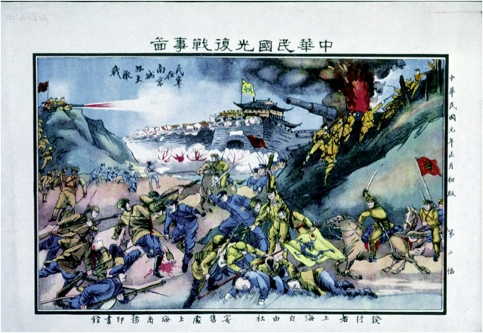

*1911 Revolutionary Poster*

**This is the 11th seminar presented by the National Consortium for Teaching about Asia (NCTA), the Global Studies Center (UCIS), and the World History Center at the University of Pittsburgh. The general public is welcome.**

Our guest speaker will be **Dr. Kristin Stapleton**, Director of the Asian Studies Program (2007 to the present), founding Director of the Confucius Institute (established in 2010), and Associate Professor, Department of History, University at Buffalo, SUNY. She has had extensive experience with NCTA as the China expert on several study tours as well as serving as a seminar leader in Kentucky. Dr. Stapleton’s research interests focus on the late Qing Dynasty and the Republican Period. Her most recent monograph is entitled *Civilizing Chengdu: Chinese Urban Reform 1895-1937* and one current work in progress examines the historical background of Ba Jin’s 1931 novel, *Jia* (family).

**METHOD OF PRESENTATION**: In addition to Dr. Stapleton’s formal talk there will be an open discussion of the key issues of this revolutionary period: political transformation, family reform and women’s reform. To support this discussion a series of important documents will be excerpted and either posted on line or sent to you in hard copy. Among these are the following: Ye Shengtao’s *Is This Also a Human Being?* an excerpt from Ba Jin’s *Family,* and Deng Yingchao’s *The Spirit of the May*

*Fourth Movement.*

**PARKING**: Vouchers for the Soldiers and Sailors Garage will be distributed during the seminar.

**ACT 48**: Requests for Act 48 credit may be submitted.

**FOOD**: A light snack and drinks will be provided.

**THIS SEMINAR IS FREE & OPEN TO THE PUBLIC. YOU NEED NOT HAVE ATTENDED THE PREVIOUS SESSIONS TO PARTICIPATE IN THIS SEMINAR.**

-------------------------------------------------------------------------------------------------------- **NCTA, Global Studies Center (UCIS), and the World History Center all at the University of Pittsburgh**

**China’s 1911 Revolution: How it Continues to Influence China (and the World)**

**REGISTRATION**

Please return the following information by **Friday, Sepember 16** by **fax** (412-624-4665), by **email** (hughespw@pitt.edu) or by **mail**: NCTA, Asian Studies Center, 4400 Wesley W Posvar Hall, University of Pittsburgh, Pittsburgh, PA 15260.

Name: ___________________________

Email: ____________________________

Name of School at which you teach: ______________________________

Subjects you teach: ______________________________________