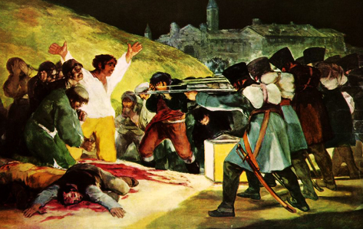**Symposium on Political Violence**

*We cordially invite you to join us for*

*a lecture by* ***Laura Paler*** *of the*

*Department of Political Science, University of Pittsburgh*

Friday, November 8 - 12:00 PM - 1:30 PM  
Posvar 3610  
Paper TBD

Center for International studies C:\Users\corrigan\Dropbox\Screenshots\Screenshot 2013-10-17 08.47.42.png

  