How to Enroll to the Global Studies Certificates (Undergraduate and Graduate)

Step 1: Download and install the Suitable App
Step 2: Once installed, log in to suitable using your pitt e-mail (you may be required to verify your account, please follow the instructions)
Your Pitt Email

Use your Pitt account password to login. 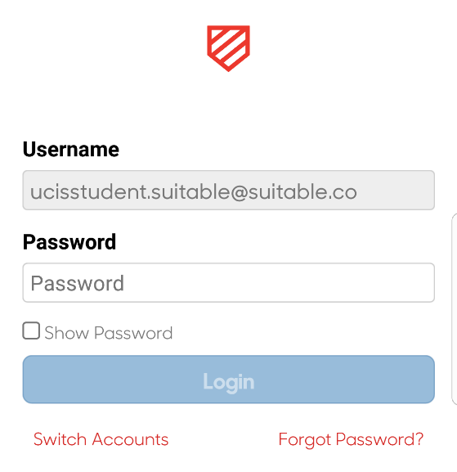
Your Pitt Email

Your Pitt Password

Step 3: Click on categories (see image below)
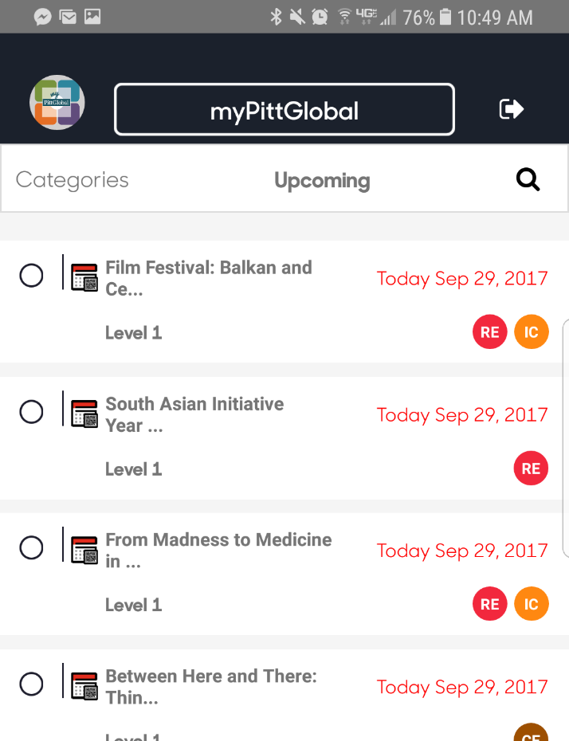
Click here

Step 4: Choose all (See image below)
Click here

Step 5: Click the Search button
Click here

Step 6: Enter the enrollment Search (Undergraduate and Graduate)
Undergraduate
- For the Global Studies Undergraduate Certificate enter (gscug) Undergraduate Enrollment (below)

Click here

Type here first

Graduate
- For the Global Studies Graduate Certifiate enter (gscg) graduate enrollment
Click here

Type here first

