15th Century Kosovar Hero

*Skanderbeg (skăn´dərbĕg), c.1404–1468*

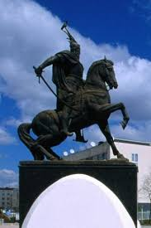

Skanderbeg was the son of a Albania prince. At the age of three he was sent as a hostage to be held by a Turkish sultan. The sultan raised the boy in his court where he learned the Muslim faith. His original name was George Castriota (*Gjergj Kastrioti)*, but the sultan called him Iskender Bey, and this was ultimately changed into Skanderbeg.

The Turkish sultan showered favors on him. He gave him the title “bey” and an army to command. In 1443, when the Turks said they would attack Skanderbeg’s homeland of Albania, Scanderbeg escaped to his home, gave up the Muslim faith, and became a Christian. He formed a league of princes among the Albanian chieftains and proclaimed himself prince of Albania.

Skanderbeg was very successful fighting against the Turks. This was partly because of the mountainous land in Albania and partly because he surprised the Turks by using guerrilla (non-traditional) methods in his fighting. The Pope, who was the head of the Catholic Church, helped Skanderbeg. Skanderbeg eventually forced the sultan to call a truce in 1461. The truce lasted until 1463 when the Pope called for a crusade (religious war) against the Turks.

Adapted from http://www.encyclopedia.com/people/history/albanian-history-biographies/scanderbeg