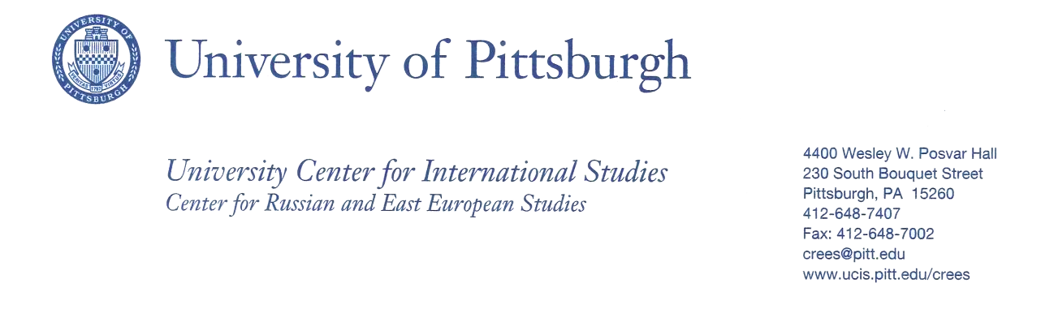
How does culture affect who you are?
A Bridging Cultures Course Module for Public Speaking

Susan Allen, Adjunct Faculty
Division of Business, Arts, Sciences, and Technology
Community College of Beaver County

Course: Public Speaking COMM201

Course Description: The emphasis is on speech preparation and delivery with a variety of speaking experiences designed to improve the speaker’s capability and apply theory to correct speech practices.

Class size: approximately 10

Course Module Title: How does culture affect who you are?

Module Description:
Students will participate in a field trip to St. Nicholas Croatian Church to learn about Croatian history. They will be required to explore at least two generations back of their heritage and culture. Students will each give a 5 minute presentation regarding their culture, traditions and the role education has played in their culture.

Learning Activities:
- Students will watch “What is Culture?” [https://www.youtube.com/watch?v=ai9pRv_t3y8 ] prior to the culture module.
- Students will attend a presentation at the St. Nicholas church on the Croatian influences in the Pittsburgh area.
- Students will be required to read the section regarding their culture in the book Kiss, Bow and Shake Hands.
- Students will give and be assessed by their oral presentation.

Learning Outcomes:
- The student will be able to understand his/her culture and how it is affected by education and how education itself has affected the culture. Students will explore their own family heritage and culture.
- Students will be able to distinguish between culture and ethnicity.
- As students are giving their presentations I will “Identify particular points of relevance of these themes for their own community college students, including those with East European immigrant familial backgrounds.”
- Students will be assessed by their oral presentation.
- A class power point presentation will be created by the class incorporating each student’s culture.
- A class bibliography will be created from the student’s research.

Reflection on the Course Module Experience:
I was very unaware of the culture of Beaver County and this grant allowed me to explore the different cultures in the area with excellent information from the seminars we had. My students, at the beginning or the semester were all sure that culture and ethnicity were the same thing. During the second week of the semester, the students did a short presentation on their culture. They all talked about ethnicity. I took the students to the Croatian church St. Nicholas for a tour and they were amazed at what they saw. One student had lived to blocks from the church most of her life and had never been there. When they asked questions, I was able to answer them with information I had gained from the seminar.

SPEECH ASSIGNMENT PROMPT
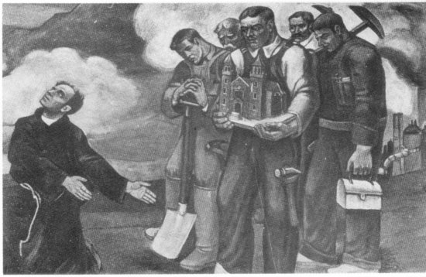

Final Speech: exploring your culture or an aspect of your culture.

As a class, we went to the Croatian church St. Nicholas in Millvale. The docent discussed the history of the murals and the Croatian people. Beaver County in Pennsylvania has a substantial Croatian population.

You are to use the visit to the church as a pathway to your final speech. For example, you may want to tell us about the history of the murals; you may want to demonstrate the types of foods your culture eats; you may want to persuade the audience to believe that without the Croatian immigration, Pittsburgh would not have been a successful city, etc.

Time limit: 3-7 minutes

Bibliography: 5 sources or more

