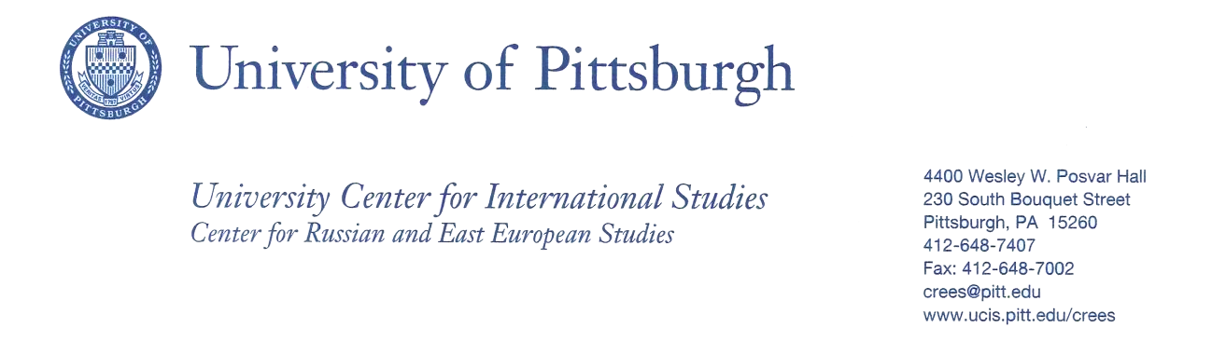
Does Education Affect Your Culture or Does Culture Affect Your Education?
A Bridging Cultures Course Module

Susan Allen, Adjunct Faculty
Division of Business, Arts, Sciences, and Technology
Community College of Beaver County

Course: College Success Strategies Course Number: COLL 101
Course Description: This course examines skills and learning strategies for success in higher education but which also apply to success in the workplace and in lifelong learning. By orienting students to academic resources and reviewing policies and procedures typical to institutions of higher education, the course empowers students to reach their educational and professional goals. This is a Liberal Arts course.
One of the objectives in the course is to “identify factors that affect academic success.” I teach culture during this part of the course and believe a student’s culture can have a great deal to do with success.
Class size: approximately 20

Course Module Title: Does Education Affect Your Culture or Does Culture Affect Your Education?
Module Description
Students will explore at least two generations back of their heritage and culture. Then each will give a 5 minute presentation regarding their culture, traditions, and the role education has played in their culture.
Description of Learning Activities
- Students will watch “What is Culture?” [ https://www.youtube.com/watch?v=ai9pRv_t3y8 ] prior to the culture module.
- Students will be required to read the section regarding their culture in the book Kiss, Bow and Shake Hands.
- Students will be assessed by their oral presentation.

Learning Objectives
- The student will be able to understand his/her culture and how it is affected by education and how education itself has affected the culture. Students will explore their own family heritage and culture.
- As students are giving their presentations I will identify points of relevance to their identity as community college students, especially for those with East European immigrant family background.
- A class power point presentation will be created by the class incorporating each student’s culture.

Bibliography
- A class bibliography will be created from the student’s research.

