Title: | I Am Because We Are, We Are Because I Am - Becoming Crew 187
School: | Frank Elementary School
Grade Level: | Kindergarten
Discipline(s): | Social Studies, Literacy, SEL
Specific Topic: | Building a Classroom Community and Understanding My Place In It
Start & End Dates: | August 19- September 20
Author(s): | Beth Smith

Standards:
SS.Hist.2: Wisconsin students will analyze, recognize, and evaluate patterns of continuity and change over time and contextualization of historical events.
SS.Hist.3: Wisconsin students will connect past events, people, and ideas to the present; use different perspectives to draw conclusions; and suggest current implications.
W.K.2- Use both drawing and writing to describe

Summary:
• Students will learn the importance of their role in our classroom community and how we are also a part of the bigger world

Essential Question:
• How Am I a Part of Crew 187? How is Crew 187 a Part of Me?

Guiding Questions:
- What is a Crew?
- What is Ubuntu?
- What is Mbongi?
- What is Sawubona?
- How Can I Contribute to Crew 187?

Learning Targets:
- I can become a part of our classroom crew
- I can demonstrate my role in our classroom crew
- I can understand how the greater world impacts my classroom crew

Anchor Text(s):

Our Class is a Family | African Proverbs for Kids | This is How We Do It | What Does it Mean to Be Global?

1. Case Study Title: | What is a Crew?
Case Study Content: | This will be the introduction to being a student in our classroom crew. This is fitting for the first weeks of school as many of my kindergarten students will be experiencing school for the first time.
Big Ideas/Broad Concepts: | - Students will understand they are a part of Crew 187  - Students will understand that we are stronger together and that we are crew, not passengers
Key Standards That Drive the Case Study: | - SS.Hist.3: Wisconsin students will connect past events, people, and ideas to the present; use different perspectives to draw conclusions; and suggest current implications.
Assessment: | • Informal assessment - thumbs up/thumbs down on who is in our crew. Teacher will show pictures of students in our class, different animals, etc. and students will respond with thumbs up/down if that person is a part of our Crew. We will place these pictures on a T-Chart listing YES or NO

2. Case Study Title: | What is Ubuntu?
Case Study Content: | Students will be able to verbalize what Ubuntu is (belonging to a community - I Am Because We are and We Are Because I Am)
Big Ideas/Broad Concepts: | Students will describe how the “I” and “WE” of Ubuntu are connected
Key Standards That Drive the Case Study: | •SS.Hist.3: Wisconsin students will connect past events, people, and ideas to the present; use different perspectives to draw conclusions; and suggest current implications.  •W.K.2- Use both drawing and writing to describe
Assessment: |   • Students will color in an outline of their hand and they will all be connected for a hallway display. They will write or trace their name on the hand.

3. Case Study Title: | What is Mbongi?
Case Study Content: | Students will be able to verbalize what Mbongi is - a community learning place
Big Ideas/Broad Concepts | Students will describe what a community is and what a learning place is
Key Standards That Drive the Case Study: | •SS.Hist.3: Wisconsin students will connect past events, people, and ideas to the present; use different perspectives to draw conclusions; and suggest current implications.  •W.K.2- Use both drawing and writing to describe
Assessment: | Students will color in different shapes that will be assembled to mimic our classroom and be added to the halfway display. They will orally share a describing word of how they feel to be in our crew and teacher will write that feeling word on one of the shapes they colored in

3. Case Study Title: | What is Sawubona?
Case Study Content: | Students will be able to verbalize what Sawubona means - I see you. Sawubona also can be a greeting - hello.
Big Ideas/Broad Concepts | Students will describe how they feel when they know someone is listening to them and “seeing them”
Key Standards That Drive the Case Study: | •SS.Hist.3: Wisconsin students will connect past events, people, and ideas to the present; use different perspectives to draw conclusions; and suggest current implications.  •W.K.2- Use both drawing and writing to describe
Assessment: | Students will color in eyes and a heart and use a describing word that tells how they feel when someone says “hello” to them

3. Case Study Title: | How Can I Contribute to Crew 187?
Case Study Content: | Students will be able to verbalize our whole brain teaching expectations - these are our classroom norms.
Big Ideas/Broad Concepts | Students will orally tell the classroom norms along with our hand actions
Key Standards That Drive the Case Study: | •SS.Hist.3: Wisconsin students will connect past events, people, and ideas to the present; use different perspectives to draw conclusions; and suggest current implications.  •W.K.2- Use both drawing and writing to describe
Assessment: | Students will color in a self portrait and write or trace their name - which will be added to our hallway display

Final Product:
- Crew 187 will present three new vocabulary words at our all school Community Circle. We will share our Crew Greeting: Sawubona, our new word for our learning space: Mbongi, and our Class Motto: Ubuntu

Connections to the Community and the Larger World:
This unit will be a second week of school activity. We will be building our classroom community and seeing how our classroom fits into our school community and our neighborhood community.

Fieldwork: | • none - too early in the year
Experts: | • school counselor, school social worker, SEL coordinator
Service Learning: | • We share our new vocabulary words with the other kindergarten classrooms
Expedition Kick-Off: | • Mentor Text - Our Class is a Family
Expedition Culmination: | • Hallway Display of our new knowledge

Week 1: August 19-23
19  What is a Crew?  Read Our Class is a Family and think aloud as you read. Kids can ask questions and/or share as we read | 20 | 21  Introduce the word Crew. Describe what a crew does and how we can be a crew in Room 187. | 22  Reread Our Class is a Family. Teacher shows first day of school pictures and other pictures mixed in (random people, animals, etc). and kids decide if they are part of our Crew. Pictures are placed on a YES/NO T-chart | 23

Week 2: August 26-30
26  What is Ubuntu?  Teacher displays the word. Kids clap it, count the letters in the word, and repeat the word in a variety of voices.  Teacher gives definition: I Am Because We are and We Are Because I Am  Make up hand signal to go along with definition | 27 | 28  Play video - a song about Ubuntu  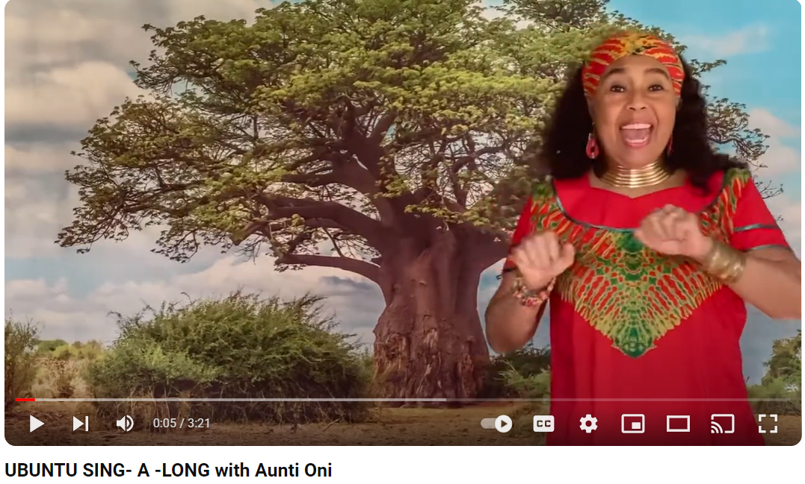 | 29  Students color in a hand and write their name on the hand (or teacher will write their name) | 30  NO SCHOOL

Week 3: September 2-6
2  NO SCHOOL | 3  What is Mbongi?  Teacher displays the word. Kids clap it, count the letters in the word, and repeat the word in a variety of voices.  Teacher gives definition: a community learning place  Make up hand signal to go along with definition | 4  Teacher shows different dwellings and kids determine if it could be a Mbongi for THEM (school, house, park, zoo, firestation, ocean, etc.) | 5 | 6  Students color in a variety of shapes that that will become part of our hallway display. Teacher will write their describing word of how they feel to be in our learning place

Week 4: September 9-13
9  What is Sawubona?  Teacher displays the word. Kids clap it, count the letters in the word, and repeat the word in a variety of voices.  Teacher gives definition: I See You  Make up hand signal to go along with definition | 10 | 11  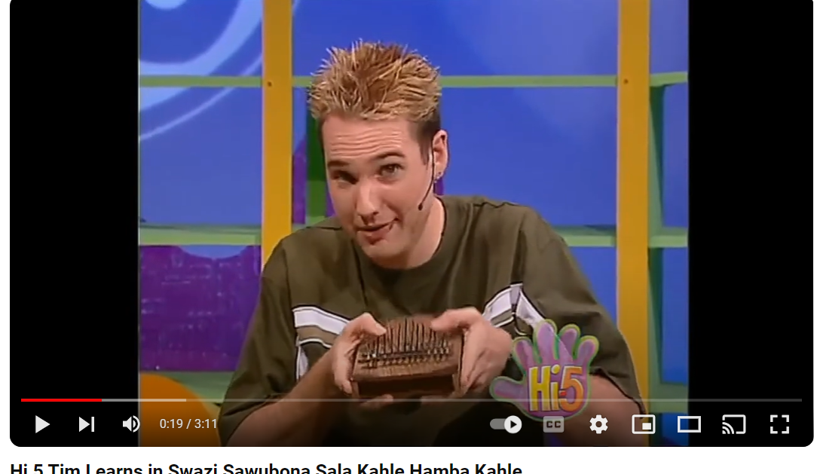 | 12 | 13  Kids color in a pair of eyes and a heart to signify “I see you”. Kids will dictate how they feel when someone says hello to them

Week 5: September 16-20
16  How Can I Contribute to Crew 187?  Teacher reads This is How We Do It. Think aloud as we read. Kids can ask questions and/or share as we read | 17 | 18 | 19  Teacher reads What Does It Mean To Be Global? Think aloud as we read. Kids can ask questions and/or share as we read | 20  Kids make a self-portrait and write their name on the bottom. This is added to the hallway display

