Refugee-Themed Book Clubs
(A 5th Grade ELA Unit by Karen Gaul, Winchester Thurston School)

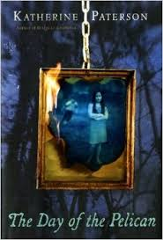
Book Clubs introduce reading to students as an interactive, social experience. Also referred to as Literature Circles, Book Clubs are meant to give students an opportunity to use what they’ve learned about reading and understanding books in a student-directed and social context.

All of the books in our fifth grade book club unit have the common theme of immigration. The setting of each started in a country far away from Pittsburgh and ended in the United States. The four books include the following:
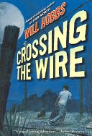
- Katherine Paterson's The Day of the Pelican
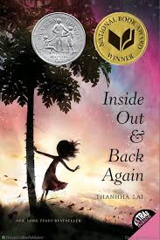
- Will Hobb’s Crossing the Wire
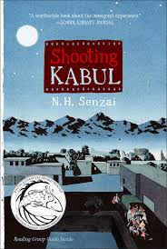
- Thanhha Lai’s Inside Out and Back Again

- N.H. Senzai’s Shooting Kabul

Our summer reading book, Linda Sue Park’s A Long Walk to Water was used as model text, and during the book club study, students learned how to
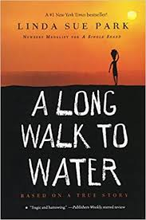
- Build understandings about a far-away setting.
- Examine the refugee experience from a child’s perspective.
- Think and talk about a text in a variety of ways.
- Collect evidence to support a theory.
- Interact socially to share information and accomplish tasks.
- Define and explore unfamiliar words.
- Recognize the author’s purpose for writing the book.

Weekly reading and related homework are assigned to students. Additionally, the students meet in small groups each week to discuss their readings. The homework packet is used to guide these discussions.

Supporting information given to students during this unit include country profiles, country images, maps, infographics and background readings

