Entry into the European Union
Introduction
Since its founding in 1957, the European Union has growth from its original six members to a Union of 28 nations (27 pending the formal withdrawal of the United Kingdom) that include over 500 million individuals. The vote of the United Kingdom notwithstanding, European Union membership remains attractive to several nations, mainly in Eastern Europe, due to the political, economic, and security advantages that membership entails.
Any nation that is “European” may apply for membership, and Article 49 of the Maastricht Treaty states that any European state that respects the "principles of liberty, democracy, respect for human rights and fundamental freedoms, and the rule of law" may apply. However, membership is not automatic, and depending on the nation, may take years to accomplish.
Once a nation formally applies for membership, the European Commission determines the suitability of opening the negotiations process for membership. The European Council has the final authority to open membership negotiations.
To become a member of the European Union, a nation must:
- Successfully complete ascension negotiations, including fulfilling political and economic conditions known as the “Copenhagen Criteria” which ensures members respect the rule of law and citizen freedoms.
- Accept all current EU rules, including free movement of people and agreement to eventually adopt the Euro as a national currency. This is known as “acquis communautaire.”
- Be approved by all current members of the EU, as well as the European Parliament. This is required under the Maastricht Treaty.
According to the Copenhagen Criteria:
Membership requires that candidate country has achieved stability of institutions guaranteeing democracy, the rule of law, human rights, respect for and protection of minorities, the existence of a functioning market economy as well as the capacity to cope with competitive pressure and market forces within the Union. Membership presupposes the candidate's ability to take on the obligations of membership including adherence to the aims of political, economic and monetary union.
As of 2016, Montenegro, Serbia, and Turkey are in accession talks with the EU for membership. Official candidates for European Union membership include Albania and the F.Y.R. Macedonia. Bosnia and Herzegovina and Kosovo are considered potential candidates for the future.
At some point in the future, some or all of these nations may become members of the European Union, and others (Norway, Iceland, Georgia, Moldovia, Ukraine) may also join. This lesson is designed to help students understand the process and procedure by which a nation may join the European Union.
Procedure:
The teacher may begin class by posing questions to the students, such as:
- “What are arguments made in favor of enlargement of the European Union” (Possible answers include: Regional stability, collective security, economic prosperity, European integration).
- “What are some pitfalls of EU expansion” (Possible answers include “expansion fatigue,” expense of bringing in new members, difficulty of integrating new members into the EU, concerns over the potential of cheap labor moving from East to West, concerns over the reaction of Russia).
- “Why do people within the European Union want the EU to enlarge?” (Possible answers include strengthening of Democracy, human rights, protection of minorities, larger economic zone).
After having a class discussion, the teacher will inform students that they will be doing a simulation on admission of new nations into the EU. The purpose of the simulation is to show students the process of admitting new members to the EU, as well as allowing them to see which of the candidate nations are the closest to actually achieving membership.
The teacher should divide the students into several groups. One group should represent the European Union, and each student in the EU group should be allowed to select a different EU member nation to represent. To assist these students in preparing, they can use the “EU Member Profile” handout.
The other groups should each represent one of the nations listed above that are currently vying for EU membership.
Students will need time to research the different nations, and this may take several days. Students will also need to determine how to structure their presentations to the EU panel. To assist students, they can use the “Country Profile” handout.
Once students have completed their research, they can make their presentations. Presentations can take whatever format would best work for that class, but should involve all students having a speaking role. Also, each team should prepare a one-page “memo” to present to the EU panel outlining their presentation and reasons for admission. Additionally, after the presentation, students who are on the EU panel should be allowed to ask questions of the candidate countries.
At the end, the “EU Delegation” can vote to determine which of the candidate nations should be recommended to full EU membership.
At the conclusion of the activity, the teacher could pose the following questions to students:
- What nations are the closest to becoming members of the EU? Why?
- What are other factors that weigh into the decision to admit certain members into the EU?
- Why is it so difficult for new members to be admitted to the European Union?
- What will the impact of future enlargement be on the European Union?
- Will the EU continue to be attractive option for nonmembers? Why might nations choose not to join the EU?

Country Profile
Your group is responsible for preparing a case to a panel of EU Members that your nation should be granted membership into the European Union. For this activity, you will need to conduct research into your assigned nation. You will then need to create a presentation that will highlight the reasons your nation is worthy of EU membership. Included in this presentation is a one-page summary of your arguments. This presentation will be shared with the EU panel members.

Your presentation should specifically cover:
- The current economic status of your nation
  - Does your nation have a market economy?
  - Is your economy strong enough to compete in the EU Common Market?
- The current political status of your nation
  - How stable is Democracy in your nation?
  - Do the political leaders in your nation respect the rule of law?
- Any major political economic, social, or environmental problems in your nation, and either how they have been or will be addressed
- The status of minority groups in your nation
- The preparedness of your nation to fully join into the European Union (with regards to free trade, movement of people, and accepting EU laws)
- What are the strongest reasons your nation should be admitted into the EU?
- Address any weaknesses into your nation’s application

EU Member Profile
You will be representing a current member of the European Union on a panel evaluating new nations for admission to the EU. Along with your fellow EU member states, your panel is responsible for evaluating the case made by the applicant nations that they should be granted membership into the European Union. For this activity, you will need to conduct research into your assigned nation.
Your research should specifically cover:
- The current economic status of your nation
- The current political status of your nation
- The opinion of your nation towards the EU, specifically, EU expansion
- The feeling of your nation’s government towards the preparedness of the applicants to fully join into the European Union (with regards to free trade, movement of people, and accepting EU laws)

Prospective EU Member Review Sheet

Politics:
- Does the applicant country have stable political institutions? Y N Unsure
- Does the applicant country have democracy? Y N Unsure
- Does the applicant country have human rights for its citizens? Y N Unsure
- Does the applicant country protect minorities in the nation? Y N Unsure
- Does the applicant country respect the rule of law in the nation? Y N Unsure

Economics:
- Does the nation have a market economy? Y N Unsure
- Can the nation compete with market forces in the EU? Y N Unsure

Obligations of Membership:
- Can the country assume the obligations of membership Y N Unsure
(including adopting EU laws and ensuring its enforcement)

- In what areas does the country need to improve (for instance,
barriers to trade, movement of people, etc).

Summary and Recommendations:

Current Members of the European Union and year of joining.

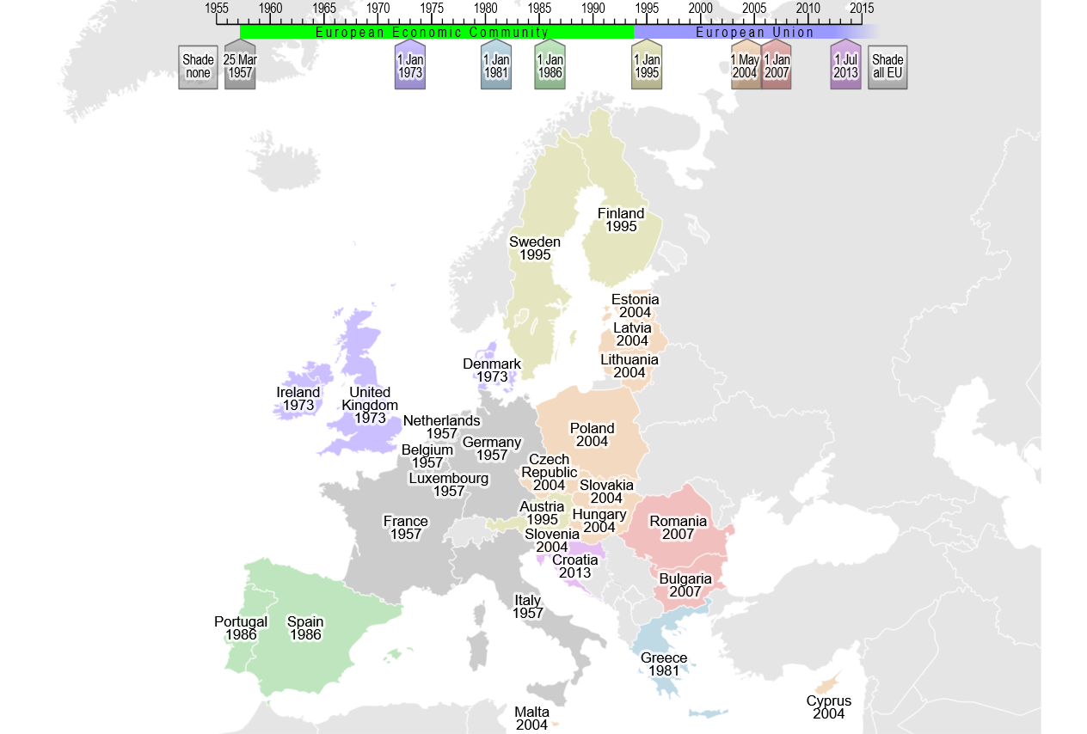
Retrieved from https://upload.wikimedia.org/wikipedia/commons/4/4d/Enlargement_of_the_European_Union_SMIL.svg

EU Simulation Rubric

Factual Accuracy ___ out of 5
5 Participation of delegate in role-play shows mastery of knowledge of subject area
4 Participation of delegate in role-play shows good command of knowledge of subject area.
3 Participation of delegate in role-play shows some knowledge of subject area.
2 Participation of delegate in role-play shows inaccurate knowledge of subject area.
1 Participation of delegate in role-play shows no knowledge of subject area.

Use of Resources ___ out of 5
5 Participation of delegate shows evidence of extensive outside research and analysis.
4 Participation of delegate shows evidence of outside research and analysis.
3 Participation of delegate shows an attempt to provide evidence of outside research and analysis.
2 Participation of delegate shows little evidence of outside research and analysis.
1 Participation of delegate shows no evidence of outside research and analysis.

Use of Skills ___ out of 5
5 Participation of delegate displays mastery of language and speech techniques appropriate to procedures.
4 Participation of delegate displays skillful use of language and speech techniques appropriate to procedures.
3 Participation of delegate displays good use of language and speech techniques appropriate to procedures.
2 Participation of delegate displays a marginal use of language and speech techniques appropriate to procedures.
1 Participation of delegate displays no use of language and speech techniques appropriate to procedures.

Participation ___ out of 5
5 Participant is present for entire simulation, demonstrates appropriate behavior, and shows extensive involvement in all phases of the simulation.
4 Participant is present for entire simulation, demonstrates appropriate behavior, and shows good involvement in all phases of the simulation.
3 Participant is present for most of the simulation, demonstrates appropriate behavior, and shows some involvement in all phases of the simulation.
2 Participant is absent for most of the simulation, demonstrates appropriate behavior some of the time and shows little involvement in all phases of the simulation.
1 Participant’s absence and/or presence had a negative impact on the simulation, did not demonstrate appropriate behavior, and shows no involvement in any of the phases of the simulation.

Total ________ out of 20

