The Proposal: The Schengen Area
What’s the big idea?

The free movement of persons is a fundamental right guaranteed by the EU to its citizens. The Schengen Area would entitle every EU citizen to travel, work and live in any EU country without special formalities.

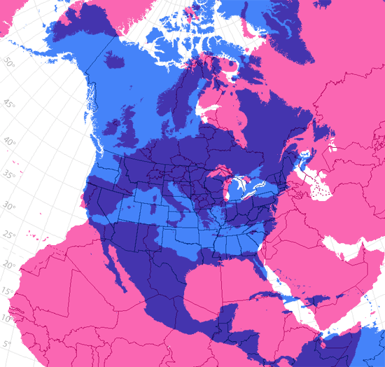
Pros:
- EU citizens whose countries join the Schengen Area will be able to cross internal borders without being subjected to border checks (no need for passports).
- This is a big deal! Europe is much smaller than the U.S., so people travel between countries frequently. (Examine map on your right.)
- EU citizens would be able to search for jobs and housing across borders.
- The rules for travelling will be the same throughout the Schengen Area.
- Criminals can be extradited (or handing over a criminal or accused person to the country where they supposedly committed the crime) much faster within the Schengen Area. Without this, criminals are sometimes able to hide from justice in other countries within Europe.
Bill Rankin (http://www.radicalcartography.net/index.)
- U.S. citizens will also be able to travel to your country without having to get special paper work called a visa, so it will be less expensive and less of a hassle.
Unknown:
- Will borders just cease to exist? What will this look like in real-life?

Cons:
- Richer countries will have an influx of citizens from poorer nations, once the restriction on migration (or movement of people) is lifted. This can be expensive for the richer nations.
- Countries will lose the ability to control how many people are moving into their country.
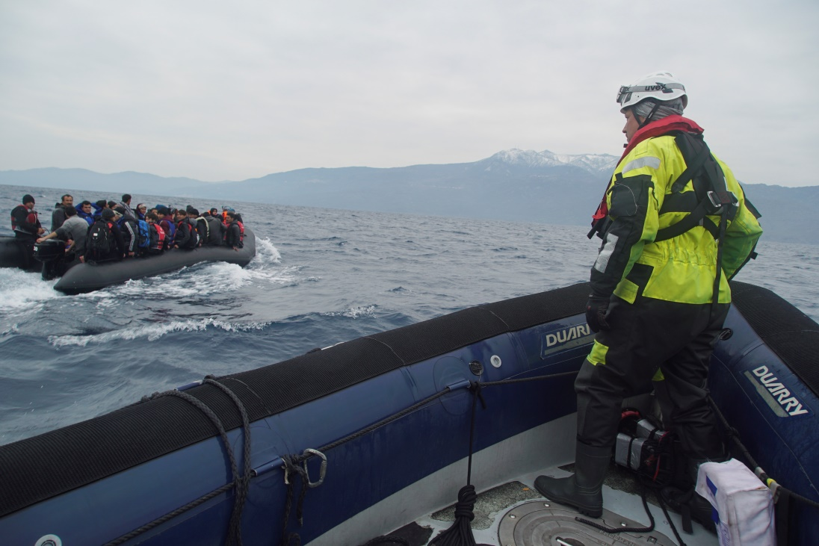
- If an undesirable (like terrorists or criminals) manage to breach the border of a careless nation, they would be able to reach any Schengen Area nation. So, nations would lose some control of their national security.

Date to Decide:
Countries must decide whether or not to join by ____________because the experiment will begin in 1985 and will be implemented over the next decade.

What should your country do?

Give rationale to support why.

How will you convince your countrymen to see things your way? (Anticipate what your opponent might say, and be ready with a rebuttal!)

