**The Proposal: The Euro Zone**

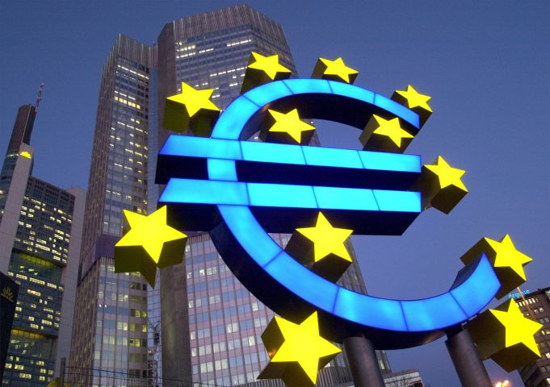**What’s the big idea?**

AP/Bernd Kammerer

We need to share a **currency** (which is another name for a type of money, like the U.S. dollar) in order to bind the European Union countries together into a **Euro Zone** or “common market.” With almost 30 EU countries and over 500 million citizens, we could become one of the most powerful currencies in the world.

**Pros:**

* Travelers will not need to exchange money, which can be costly and expensive (they charge you fee, like at an ATM).
* Companies will be more willing to do business across borders because it will be easier.
* Buying things online from other EU nations will be easier and less expensive. (You won’t need to do the math to figure out the exchange rate!)
  + *Example*: You want to buy two DVD online from a French website. The set of 2 DVDs costs 15 **francs** (the name for French currency). But you live in England, which uses the **pound** (the name for the English currency). Right now, 7 pounds=5 francs. How much will *each* DVD end up costing you in pounds?
  + *Getting the right answer to this can earn you stamps!*
  + As if that wasn’t enough of a hassle, remember that the **exchange rate** (or the amount of money your currency is worth) differs in every country and changes constantly! What a hassle!
* It should stimulate trade and improve the economies of all countries involved.

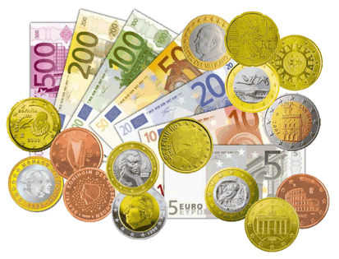**Unknowns:**

* How many countries will join? Will it be enough to make our currency powerful compared to foreign currencies like the U.S. dollar?
* What will happen with the currency people already have?
* Stability of economy vs. control of it? Think of boats to understand this concept:
  + Small boats are very easy to control and move. If it is going in the wrong direction or you sense danger, it is possible to stop or turn around. The same can be said of smaller economies. Governments have tools (like changing the amount of money available 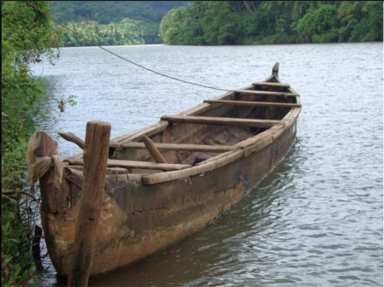or how much they lend out to people) which they use to control their economy. Sometimes these methods can avoid disaster—like an **economic depression** (a long period where businesses fail, the amount of “stuff” the country makes decreases, and many people are unemployed). It’s not fool-proof, but smaller economies, like smaller boats, have more control over going in the wrong direction.
  + Big ships are the opposite. Trying to turn around an ocean liner is difficult and time-consuming. The same can be said of turning around a large economy.
  + But, big ships are much more stable than small boats. It would take a *MAJOR* storm to cause problems for the ship you see below, but imagine what would happen with the row boat in even slightly rough water! Economies are the same way. The big guys can weather economic storms, while the little guys might get overturned when the seas get rough.
  + 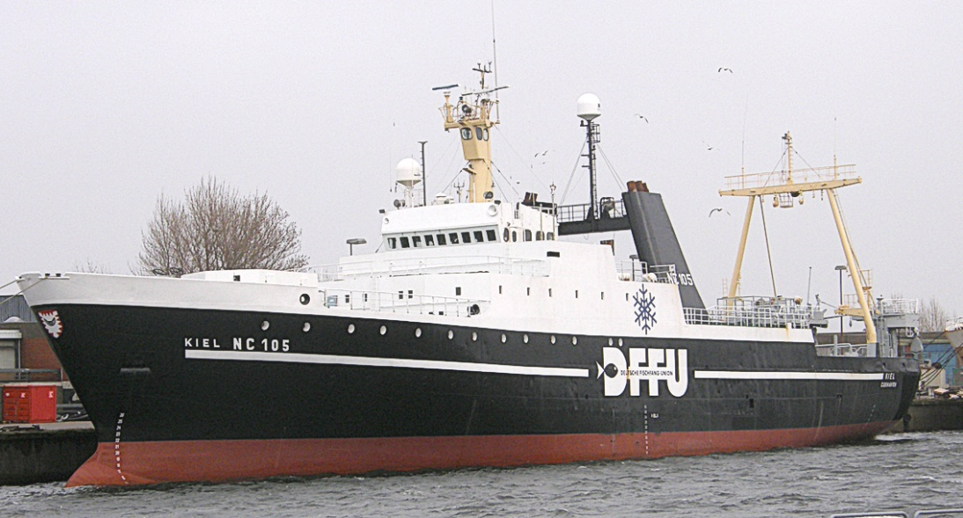Long story short, a Big Economy (like the Euro Zone) will be harder to control but also more stable. Smaller economies (like individual countries that stay out of the Euro Zone) will have less stability but more control.

**Cons:**

* Rich countries will see the value of their money lowered if they join the Euro Zone because the exchange rate of the Euro will be decided by considering the value of currencies in all the countries. (Think of it like an average.)
* If there is an economic crisis, the countries will have to deal with it together, so each country would lose some independence.
* If it is cheaper to produce something in another country, jobs could leave your country and go to that one.
* If any of the countries are irresponsible (spend too much, tax too little, etc.) you will be responsible along with them.

**Date to Decide:**

Countries must decide whether or not to use the Euro by ____________because the experiment will begin on January 1, 1999. Actual paper bills and coins will be issued within three years.

**What should your country do?**

**Give rationale to support why.**

**How will you convince your countrymen to see things your way? (Anticipate what your opponent might say, and be ready with a rebuttal!)**