The Dilemma: The Debt Crisis
WHAT IS THE EUROPEAN DEBT CRISIS?
In its most basic form-- Some countries in Europe have way too much debt (owing more money than they have), and now they risk not being able to pay it all back. Simple, right?
Well…there’s more to it than that, of course. When people talk about the “crisis,” what they’re worried about is the possibility that one or more countries will exit the Euro Zone (the 17-nation bloc that uses the Euro currency, which has been around since 1999). Should any of the Eurozone nations drop out of this group, it could lead to many bank failures in Europe, and possibly in the United States as well. (What is a bank failure? It’s when a bank goes under and the people who kept their money in the bank can lose everything!) Under these circumstances, people and businesses that need money might not be able to get any. We’d be looking at depression (in economics, it’s a long period where many people lose their jobs and the amount of money a country makes decreases drastically).
HOW DID THIS HAPPEN? Some Eurozone countries have too much debt relative to the size of their economies. And the troubles of a few countries could end up affecting everyone, since they’ve had one currency for over a decade.
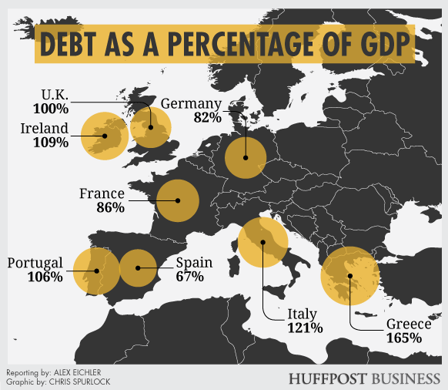

GDP stands for Gross Domestic Product, or the total value of all the "stuff" a country makes. The higher the GDP, the richer the nation.
Notice that some of these countries have debts (meaning they owe) almost as much as they make, or in some cases even more!
Portugal, Ireland, Italy, Greece and Spain are the countries in trouble. Most people think that if a disaster happens, it will start with one of them. Italy’s debt is 121 percent the size of its economy. For Ireland, that figure is 109 percent. In Greece, it’s 165 percent! (This means that they over owe 1.5 times as much money as they make in a year!)
These countries all have different causes for their troubles. For example, Greece borrowed beyond its means and seriously overspent. Plus, they did some “creative” record keeping so that the EU wouldn’t find out how bad the situation was. (In other words, they lied about how bad things were.)
The deficits weren’t piling up everywhere. Countries with strong economies like Germany and France were keeping their GDP high and their debt at a low level. But when 17 nations use the same currency, trouble spreads quickly.
Now that the size of the debt crisis has become clear, investors (people who loan money to nations and businesses in hopes of earning money back) don’t want to invest in European countries. They are afraid of losing their money, since many of those countries are heavily in debt — and the ones that aren’t in debt look like they might have to bail out the ones that are. The EU members have a lot of debt and not much money — and it’s not clear how they’re going to correct this.
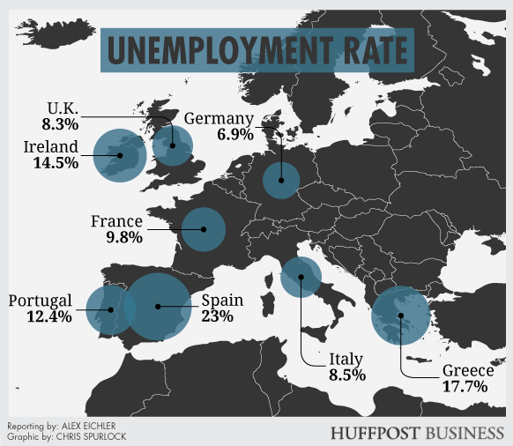
WHAT HAPPENS NEXT? Well, that’s up to you!
Options:
- Austerity—Make the debtor nations (like Greece) pay back their debts, by cutting services (healthcare, retirement, unemployment) and raising taxes.
  - Pro—It requires the countries who caused the problem to fix it, which seems fair.
  - Con—It might not work and could potentially crash the entire European economy. Could lead to violence in debtor nations.
- Bail-Out—The economically stable nations (led by Germany) give more loans to the debtor nations so that their economies don’t collapse.
  - Pro—It will work short-term in preventing economic disaster. If your neighbor’s house is on fire, you put it out for two reasons—it’s the right thing to do and it might save your house from burning down too.
  - Con—It is only a short-term fix and could be a never-ending cycle. It seems unfair to the countries who were fiscally responsible.
- Leave the Euro Zone—This experiment has failed, it’s time to go back to national currencies (each country having their own economy).
  - Pro—Allows each country to control their own destiny. (Small ship=better control)
  - Con—Would lose all of the economic benefits the Euro Zone created—stability, growth, etc.
- Strengthen the Euro Zone—The experiment just needs tweaking. If we are to share a currency, then we must have stronger rules about using it and ways to control nations who don’t abide by them (like the debtor nations).
  - Pro—Keeps the Euro Zone and all of its benefits intact.
  - Con—Nations lose the majority of control over their own economy. This will be unpopular within nations both rich and poor.
Date to Decide: Countries must decide their plan of action by ____________because with the collapse of the U.S. Housing Market (Real Estate) in 2008, we need to deal with this issue, ASAP!
If you need more information (or explanation to decide), check out these resources:
- Read the article from (Newsela) It is available at different reading levels.
https://newsela.com/articles/greecedebt-germany/id/11073/
- The European Debt Crisis Visualized (Bloomberg)
https://www.youtube.com/watch?v=j4_tyEl84IQ
What should your country do?

Give rationale to support why.

How will you convince your countrymen to see things your way? (Anticipate what your opponent might say, and be ready with a rebuttal!)

