The Dilemma:

A Migration Crisis

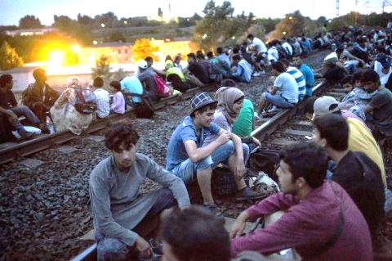
Key Questions:

Why is this happening?

Eight reasons Europe’s refugee crisis is happening now
Migrants and refugees wait on the railway tracks near Tatabanya, west of Budapest. (Balazs Mohai/EPA)
By Liz Sly
September 18, 2015
A complicated mix of war, weather and logic explains why so many refugees (people fleeing violence and/or war) and migrants (people moving for other reasons) are trying to move into Europe. Here are eight of the reasons that the biggest migration of people to the continent since World War II is happening now.
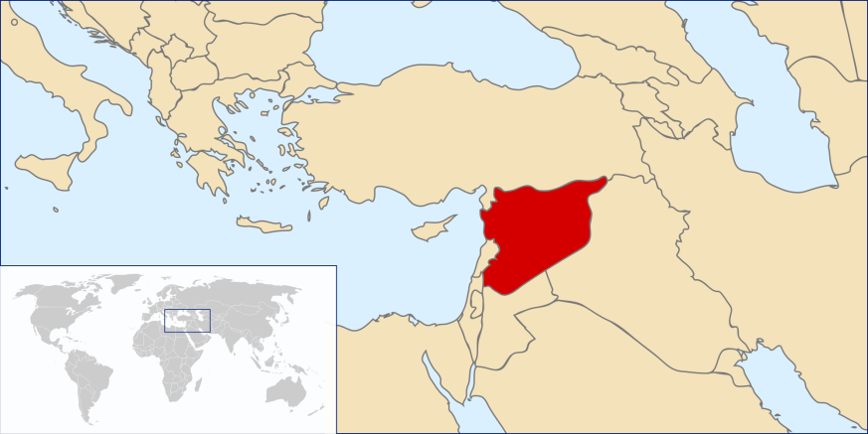
1. The War in Syria
Syria’s civil war (a war fought among members of the same country) has ground on for five years. There is no end in sight. At least 470,000 have died. It is no wonder people want to escape! Without Syrians, the influx of people seeking sanctuary (a safe place) in Europe would be roughly where it was last year.

People also are fleeing conflict in countries such as Iraq, Afghanistan, Eritrea, Somalia and Niger.

2. The route to Europe got a lot easier.
Until recently, the sea crossing from Libya to Italy had been the preferred route for all the migrants and refugees fleeing to Europe. A far shorter and less dangerous sea route exists from Turkey to Greece. After Macedonia lifted harsh measures aimed at preventing refugees from entering the country in June, the route through the Balkans opened up.

3. The price dropped.
This is linked to reason No. 2. The crossing to Greece from Turkey takes less than an hour and as little as 20 minutes, depending on which beach the boat sets out from. Not only does this make the sea crossing cheaper, but refugees no longer needed to pay smugglers to sneak them through the borders. Smugglers are now charging about $2,000 to $3,000 instead of the $5,000 to $6,000.

4. The Weather
It is normal for illegal migration into Europe to peak during the summer months, when the sea crossings are safer. One reason rush now is that a lot of people are trying to make the journey before bad weather sets in.

5. Germany extended a welcome to refugees.
Huge numbers were already on the march when German Chancellor Angela Merkel (their political leader, like our President) announced that Germany would offer temporary homes to all the refugees arriving there. No one doubts that the offer encouraged more people to set out.

6. The Syrian government’s conscription drive.
Short of manpower to fight the civil war, Syrian President Bashar al-Assad’s government has begun rounding up young men to fight. Many of the Syrians fleeing to Europe are escaping the military trying to round them up and force them to fight. This is called conscription (or mandatory military service) and it applies to all men under the age of about 30.

7. The Syrian government has made it easier for Syrians to travel.
Syrian President Bashar al-Assad has done nothing to prevent young men who want to avoid military service from leaving the country. On the contrary, the government has made it easier to acquire passports in recent months and it is possible to buy your way out of fight with a payment of $300.

8. The shortcomings of the underfunded international aid effort.
Before this massive influx of people to Europe, 4 million Syrians had already fled their country’s war to neighboring countries, mostly to Turkey, Jordan and Lebanon. There they are living miserable lives, denied the right to work, and most of the children are not in school. Many of the refugees headed for Europe who were already living as refugees cite their children’s education as the main reason they are seeking to build new lives.

What exactly is happening?

EU migration crisis: facts, figures and disappointments
EU leaders have been slow to react to the refugee crisis, but refugees continue to arrive in Europe in large numbers.
Last year more than one million people crossed the Mediterranean Sea in the attempt to reach Europe, nearly 4,000 of them dying on the way. The number of refugees crossing the sea from Turkey to Greece increased 20 times from 2014 to 2015. The number of refugees crossing the sea from Turkey to Greece increased 20 times from 2014 to 2015.
The Syrian conflict has left 13.5 million people in need of humanitarian assistance (helping people with basic human needs like food, water, and shelter).

The Origins of Refugees
Overall, 48% of the refugees that managed to cross the Mediterranean were Syrian, 21% were Afghans, 9% Iraqi and 4% Eritreans.
Greece has received 74,052 refugees so far this year, and it is expected that the bulk of refugees will continue to arrive on Greek shores.
A UNHCR report predicts that up to 1 million more refugees and migrants could come to Europe in 2016. The situation continues to escalate.

Where do they go?
Very few migrants stay in Greece. The number of Syrian asylum applications received by EU countries (plus Norway and Switzerland) reached almost 600,000 at the end of 2015. Germany and Sweden receive over half of all applications, with Hungary, Austria, the Netherlands, Denmark and Bulgaria accounting for another 30%.
For migrants and refugees, Greece is the door to Western and Northern Europe where they can receive more aid and services.
In September Hungary took measures to block the refugees, including building a 110 mile long fence along their border with Serbia. This redirected people but didn’t stop them.

Europe’s response to the refugee crisis: slow and confused
The people of the Greek islands, where the refugees first arrived have shown great “empathy and self-sacrifice” but the overall European response has been slow and disorganized.
EU countries agreed on a plan to help Greece and Italy deal with the influx of refugees last year. But relocating their refugees to other nations has been very slow. Meanwhile the migrants keep coming. If relocation continues at the current speed, it will take more than 100 years to achieve the planned relocation from Greece!
Worse still, trapping hundreds of thousands of refugees in struggling EU nations, like Greece, could create explosive situations!
These figures give an idea of the scale of the emergency. As the migrant crisis ratchets up the pressure on already struggling EU, the world will be watching.
Date to Decide: Countries must decide their plan of action ASAP! We will be debating and voting on this issue: ____________________.

- What should we do?
Options: This time, you need to develop ideas about what to do yourself.

If you need more information (or explanation to decide), check out these resources:
- What they Carried: Refugees’ Worldly Possessions in Pictures (Time Magazine) http://www.telegraph.co.uk/news/worldnews/europe/11993282/What-they-carried-Refugees-wordly-possessions-in-pictures.html?frame=3499635
- Hungary Stops Train Travel Article (Newsela) You are able to change the reading level if needed. https://newsela.com/articles/migrants-hungary/id/11905/
- Passport-Free Travel Under Threat in Europe (NPR Audio Clip)
http://www.npr.org/2016/01/26/464399968/passport-free-travel-under-threat-in-europe
What should your country do? (Be specific.)

Give rationale to support why.

How will you convince your countrymen to see things your way? (Anticipate what your opponent might say, and be ready with a rebuttal!)

