The Dilemma: Exit from the EU

There have always been people and political parties opposing the European Union for a variety of reasons. It is complex organization and often misunderstood. It takes political sovereignty (control, or the ability to reign) away from independent nations. These voices have become louder since the EU faced both the debt crisis and the migration crisis.

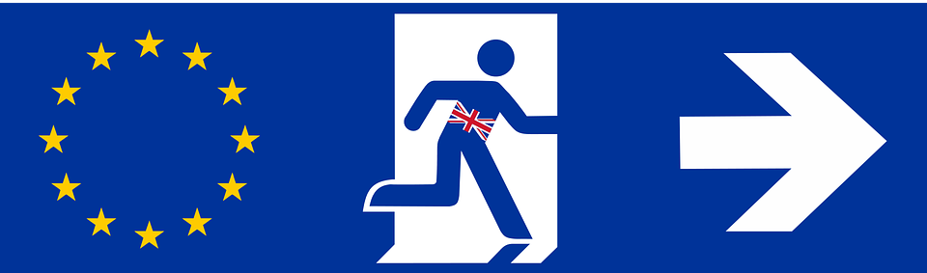
One such party, the United Kingdom Independence Party (UKIP), earned 13% of the vote during the 2015 election in Britain. In order to get re-elected, the Prime Minister of Great Britain, David Cameron promised the UKIP voters that he would hold a referendum to see if the United Kingdom should stay in the European Union moving forward. A referendum (is a vote in which everyone of voting age can take part) will be held on Thursday, June 23, 2016 to decide whether the UK should leave or remain in the European Union.
The concept of the UK leaving the EU has been dubbed, “Brexit,” short for British Exit.
Despite the cute nickname, this is a serious issue. You need to learn as much as you can about the issue and make some important decisions!
Date to Decide: The UK will vote on June 23, 2016. Other countries will need to make their decisions after that. We will be debating and voting on this issue: ____________________.

- First things, first, we need to get some of the facts. We will be watching some video clips, please watch them carefully.
  - Brexit Debate (We’ll only be watching about 9-10 minutes of this. If you are absent, please ask your teacher for what parts to watch.) https://www.youtube.com/watch?v=slqc3UcMKL4
  - Leave Campaign Commercial https://www.youtube.com/watch?v=0tItgGcWVHw
  - Remain Campaign Commercial https://www.youtube.com/watch?v=axqBPz6ikV
While you’re watching jot down any facts or arguments that you think support the argument to remain or leave. If you feel a fact is important but don’t know how to interpret it, feel free to jot it down in the center column.
Supporting Facts to Remain in the EU | Undecided Information | Supporting Facts to Leave the EU
What do you think that the UK should do? Why?

- Now discuss with your countrymen two of the following questions:
  - If you are the United Kingdom, debate the issue and hold your referendum. Should you stay or should you go now?

  - If you are any other country, how should you handle a possible UK exit from the EU? Why?

  - Finally, how does your country feel about their continued membership in the EU? Why?

This is our last combined-class debating topic. We will be debriefing and reflecting on our experiences in the days to come, so if you finish early and would like to start organizing your thoughts, please do so here.

Ex:
- What did you learn during this simulation?
- At what things did you excel?
- What was difficult about it?
- Did you develop any skills? If so, which?
- What are your overall impressions of government in general and the EU specifically?

