**Name__________________________________________ Pd._______**

**EUROPEAN UNION WEBQUEST**

***Directions: Follow the directions given in the document to learn more about the European Union.***

**EUROPEAN UNION**

**The European Union (EU) is an organization of democratic states working cooperatively for peace and prosperity. Today there are 28 member countries representing more than 500 million people. The idea of the EU took root following the devastation of World War II. The diverse nations of the EU have built upon a shared tradition of freedom, social justice, and economic vitality to create institutions that make democratic decisions on matters of joint interest.**

**Due to its gradual evolution and need to balance the needs and demands of its members while accounting for their history and sensitivities, the European Union is a complex entity. There are seven institutions of the European Union that are its “decision making bodies,” they include the European Council, the Council of the European Union, the European Parliament, the European Commission, the Court of Justice of the European Union, the European Central Bank, and the European Court of Auditors.**

**This WebQuest will help you to learn more about the European Union, as well as its seven institutions, the Euro, and the Treaties that have helped the EU evolve to its current state.**

**Go to europa.eu. Click on the link “About the EU” and answer the following questions under “Basic Information”**

1. *“European Symbols.”*
   1. Describe the appearance and symbolism of the European flag.
   2. How did this become the flag of the European Union?
   3. What is the motto of the EU?
   4. What does the motto symbolize?
   5. What is the European anthem?
   6. What does it symbolize?
2. *“Money and the EU”*
   1. How is the EU funded?
   2. How many nations use the Euro today? How many people use the Euro today?
   3. What is the purpose of the Euro?

**At the bottom of the page, click on the link that says “The Euro” or go to http://ec.europa.eu/economy_finance/euro/index_en.htm**

1. What two nations are not required to adopt the Euro?
2. Under “why do we need it?” What are some of the benefits of the Euro?
3. *“Facts and Figures”*
   1. What nation is the largest in the EU? The smallest?
   2. What is the GDP of the EU? How does that compare to the US?
   3. How many official languages does the EU have?
   4. The three main “capitols” of the EU are Brussels, Strasbourg, and Luxembourg. What are headquartered at each?
4. *“History”* 
   1. What was the “Schuman plan?”

**Click on “Institutions and Bodies”**

1. *European Parliament*
2. What is the role of the European Parliament?
3. How many Members (MEP’s) does the European Parliament have?
4. Who is the President of the European Parliament?
5. When were the first direct elections to the European Parliament?
6. The European Parliament is the EU’s _______________________________________
7. How often do elections occur?
8. What are the three main roles of the European Parliament?
9. How is composition in the European Parliament determined?
10. How many committees does the European Parliament have?
11. *European Council*
12. What is the role of the European Council?
13. Who are the members of the European Council?
14. Who is the President of the European Council?
15. When was the European Council established?
16. How often does the European Council meet?
17. What does the European Council do?
18. How does one become President of the European Council? What is their term?
19. How is voting conducted in the European Council?
20. *Council of the European Union*
21. What is the role of the Council of the European Union?
22. Who are the members of the Council of the European Union?
23. Who is the President of the Council of the European Union? What determines this?
24. When was the Council of the European Union established?
25. Together with the European Parliament, the Council of the European Union is what?
26. What does the Council of the European Union do?
27. How many “configurations” of the Council of the European Union exist? Why?
28. Who chairs meetings?
29. Describe how voting works in the Council of the European Union?
30. *European Commission*
31. What is the role of the European Commission?
32. How many commissioners are there?
33. Who is the President of the European Commission?
34. When was the European Commission established?
35. What does the European Commission do?
36. How is the President of the European Commission selected?
37. How is the “team” of Commissioners selected?
38. Describe how “collective decision making” takes place in the European Commission
39. *Court of Justice of the European Union (CJEU or ECJ)*
40. What is the role of the ECJ?
41. Who are the members of the ECJ?
42. What does the ECJ do?
43. How long are the terms of Judges in the ECJ?
44. Typically, how many judges will hear a case?
45. *European Central Bank (ECB):*
46. What is the role of the ECB?
47. Who is the President of the ECB?
48. Who are the members of the ECB?
49. What does the ECB do?
50. How does the ECB work?
51. *European Court of Auditors (ECA):*
52. What is the role of the ECA?
53. What does the ECA do?
54. How many auditors are there? How are they selected?
55. *European External Action Service (EEAS):*
56. What is the role of the EEAS?
57. Who is the High Representative for Foreign Affairs & Security Policy
58. When was the EEAS created?
59. What does the EEAS do?

**Click on “EU Law,” then “EU Treaties” Briefly describe what each of the following treaties did:**

1. Treaty establishing the European Coal and Steel Community
2. Treaty of Rome
3. Single European Act
4. Maastricht Treaty
5. Treaty of Amsterdam
6. Treaty of Nice
7. Treaty of Lisbon

*“How EU Decisions are made”*

1. What is the EU standard decision making procedure called?
2. What does it mean?
3. What does the European Commission do prior to introducing an initiative?
4. What do the European Parliament and Council do with proposals?
5. Explain what happens if the European Parliament and Council cannot agree on a proposal?

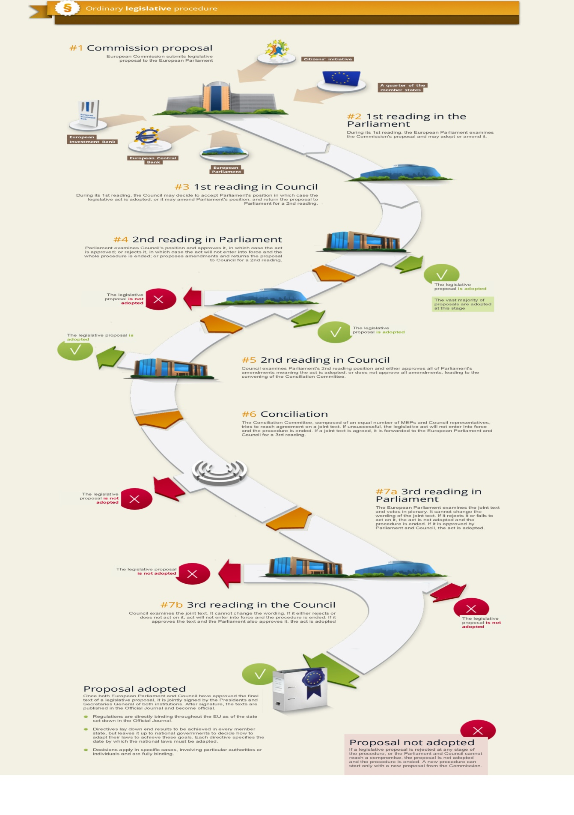Retrieved from http://www.europarl.europa.eu/external/appendix/legislativeprocedure/europarl_ordinarylegislativeprocedure_howitworks_en.pdf

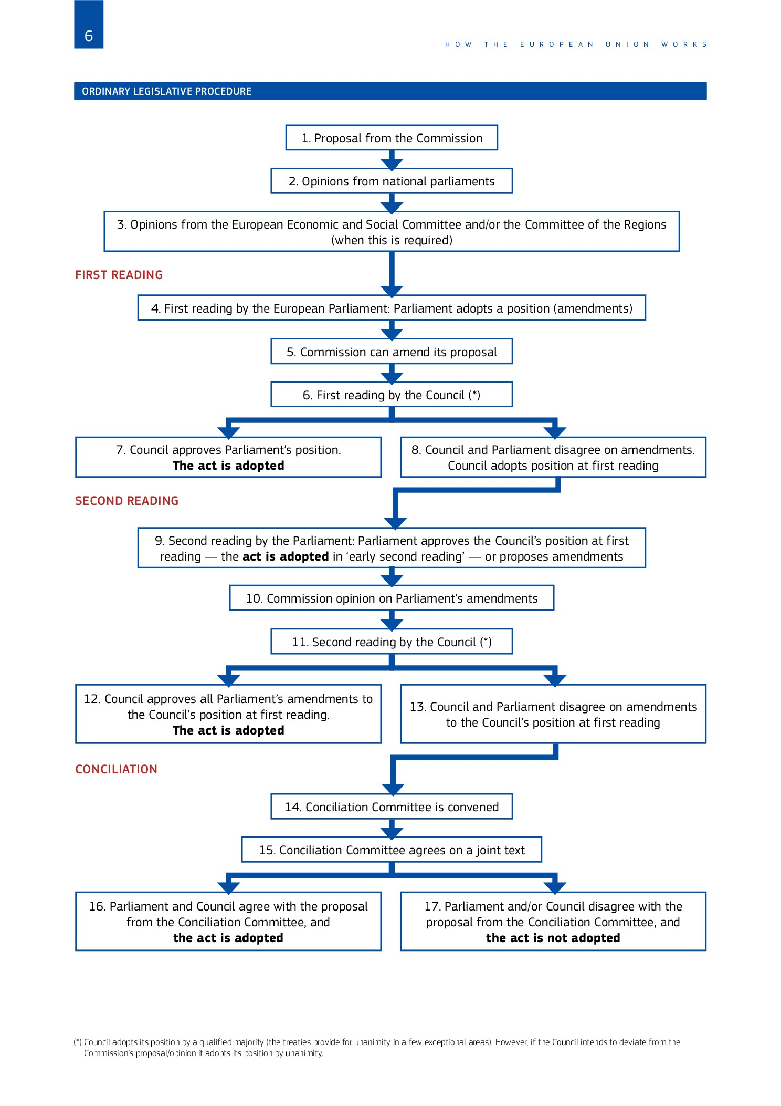

Retrieved from http://bookshop.europa.eu/en/how-the-european-union-works-pbNA0414810/

**Click on “EU by Topic”**

*“EU Citizenship”*

1. What are some of the rights and privileges EU citizens receive?

*“Climate Action”*

1. How is the EU dealing with climate change?

*“Human Rights”*

1. How is the EU promoting human rights?

*“Foreign and Security Policy”*

1. How did the Treaty of Lisbon give the EU expanded powers in this area?
2. How does the EU engage in diplomacy and peacekeeping?

*“Agriculture”*

1. What is the purpose of the EU Common Agriculture Policy (CAP)?
2. How much of the EU budget is currently spent on Agriculture?

*Education, Training, and Youth”*

1. What is the Erasmus+ program?
2. How else does the EU help education?