**Summer Institute for Global Educators 2024**

**University of Pittsburgh Center for International Studies (UCIS)**

# Teaching About & In Times of Global Conﬂict

***Sample Curriculum by Christine Gameos***

**Overview:** This curriculum uses the 6 C’s of Positive Youth Development framework and inspiring female role model stories to teach students about the refugee experience through age-appropriate discussions, books, and activities. The target audience is 3rd through 5th grade students enrolled in our after-school mentoring program. Prompt questions are built in for college mentors assisting in curriculum delivery. Take-Home questions are included to engage caregivers in the learning process and encourage further discussion at home.

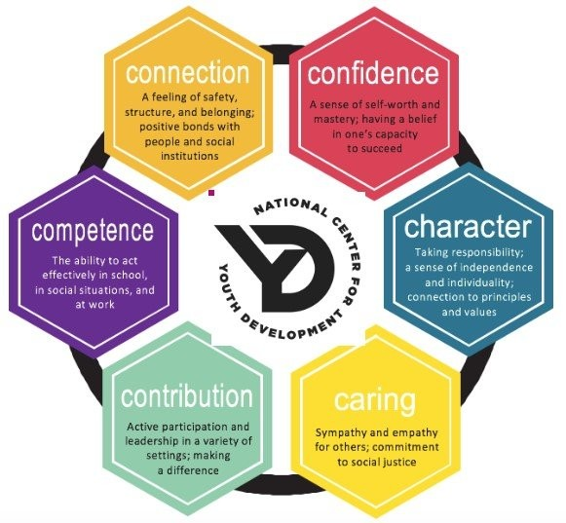

**Assumptions:**

* Students have already been brieﬂy introduced to the 6 C’s of Positive Youth Development during Week 1 of programming (not a prerequisite).
* College mentors delivering the curriculum have completed our required semiannual Mentor Training to learn about mentorship, classroom management and

trauma-informed care.

* Facilitators have taken the time to consider whether the topic matter may be extra sensitive for speciﬁc students, offering a trigger warning and/or adjusting the lesson accordingly to maintain a safe learning environment for all.

## Lesson 1: Competence

**Objective:** Students develop basic knowledge and skills related to understanding and supporting the refugee community.

 **Roses & Thorns:** Students share what they are excited about or feeling challenged by today (vibe check chart for shy participants).

 **Introduction to Competence:** Mentors lead an intro discussion about who a refugee is and why some people might need to leave their homes.

* + *Why might some people be forced to leave their homes? What (or who) do you think they had to leave behind?*
  + *What do you think this experience feels like for a refugee?*

 **Story Time:** Mentors read an age-appropriate story reﬂecting the refugee experience.

* + *“*[*What is a Refugee?*](https://www.amazon.com/What-Refugee-Elise-Gravel/dp/0593120051/ref%3Dpd_lpo_sccl_2/147-8578105-9656602?pd_rd_w=dBcTh&content-id=amzn1.sym.4c8c52db-06f8-4e42-8e56-912796f2ea6c&pf_rd_p=4c8c52db-06f8-4e42-8e56-912796f2ea6c&pf_rd_r=A8641BZW20THMWGRQP1E&pd_rd_wg=TyxPH&pd_rd_r=40265fb1-5785-4acd-afe0-f566acdd6fbd&pd_rd_i=0593120051&psc=1)*” by Elise Gravel*

 **Role Model Highlight:** Malala Yousafzai – Students read aloud about how she had to leave her home and how she continues to help others through education.

* + YouTube Video: [Malala Yousafzai: Fearless Voice for Education & Nobel Peace Laureate](https://youtu.be/ChQBHSL8vVg)

 **Activity:** Students use maps and rulers to trace different refugee journeys and discuss what hardships they might experience along the way.

* + *What conditions did these refugees have to travel through in their search for safety?*
  + *What do you think they missed most while away from their homes?*

 **Reﬂection:** Students share out or privately journal on what they learned about the refugee experience and how they can help new friends from different places feel welcome.

### Take-Home Questions:

1. *What did you learn about why some people become refugees?*
2. *Have you ever been far, far away from home? What did you miss? How did it feel to come home?*
3. *How can we make new friends from different places feel welcome?*

*\*To learn more about resources for our immigrant and refugee community in Pittsburgh, please contact* ***Christine Gameos*** *at* [*cnvgameos@gmail.com*](mailto:cnvgameos@gmail.com)*!*

## Lesson 2: Conﬁdence

**Objective:** Students build self-conﬁdence and empathy by understanding refugee resilience.

 **Roses & Thorns:** Students share what they are excited about or feeling challenged by today (vibe check chart for shy participants).

 **Introduction to Conﬁdence and Resilience:** Mentors lead a discussion about what it means to be resilient, like many refugees are.

* + *What are some situations in which refugees might need to be resilient?*
  + *What are some circumstances that may make it harder for refugees to be resilient?*

 **Story Time:** Mentors read an age-appropriate story reﬂecting refugee resilience.

* + *"*[*The Journey*](https://a.co/d/drMlbf8)*" by Francesca Sanna*

 **Role Model Highlight:** Nujeen Mustafa – Students read aloud about her journey as a refugee and how she overcame challenges with her disability.

* + YouTube Video: [Nujeen Mustafa | National Geographic](https://youtu.be/7rK6qzwwOi0?si=8rymfonREwZsZ8Pv)

 **Activity:** Students create a "Conﬁdence Shield" craft where they draw or write about things that make them conﬁdent and brave.

* + *What (or who) makes you feel conﬁdent and brave?*
  + *What (or who) can help you build your conﬁdence in the future?*

 **Reﬂection:** Students share out or privately journal about how they show conﬁdence and resilience, especially during tough times.

### Take-Home Questions:

1. *Can you tell me about a refugee you learned about today and how they were strong and brave?*
2. *What did you draw or write on your "Conﬁdence Shield"?*
3. *Where/when do you feel most conﬁdent?*

*\*To learn more about resources for Pittsburgh’s immigrant and refugee community, please contact* ***Christine Gameos*** *at* [*cnvgameos@gmail.com*](mailto:cnvgameos@gmail.com)*!*

## Lesson 3: Connection

**Objective:** Students learn how to create connections with the refugee community.

 **Roses & Thorns:** Students share what they are excited about or feeling challenged by today (vibe check chart for shy participants).

 **Introduction to Connections:** Mentors lead a discussion on the importance of making new friends, especially those who might be from different places.

* + *What are some things that make it hard to feel comfortable in new places?*
  + *How do you connect with people you don’t know?*

 **Story Time:** Mentors read an age-appropriate story about building new friendships with people from different backgrounds.

* + *Excerpts from “*[*Other Words For Home*](https://a.co/d/j0OQg6E)*” by Jasmine Warga*

 **Role Model Highlight:** Yusra Mardini – Students read aloud about how she built new connections in her new country and became an Olympic swimmer.

* + YouTube Video: [Yusra Mardini, A Young Refugee, Finds Safety in Her New Home](https://youtu.be/2KfHDYjUgiM?si=omusmuVWu6gu4KAI)

 **Activity:** Students explore media stations that feature art, dance, music, videos, poems created by refugees/reﬂecting the refugee experience.

* + *What do these pieces tell you about the refugee experience?*
  + *Why is art so important for helping us process difﬁcult things?*

 **Reﬂection:** Students share out or privately journal about what they learned from the art featured in the media stations activity and its connection to the refugee experience.

### Take-Home Questions:

1. *What was your favorite piece of art from the media stations today?*
2. *What kind of art or creative activities do you use to express yourself?*
3. *How do you think we can help people who are new to our community feel like they belong?*

*\*To learn more about resources for Pittsburgh’s immigrant and refugee community, please contact* ***Christine Gameos*** *at* [*cnvgameos@gmail.com*](mailto:cnvgameos@gmail.com)*!*

## Lesson 4: Character

**Objective:** Students develop a sense of ethics, integrity, and respect for others, regardless of where they come from.

 **Roses & Thorns:** Students share what they are excited about or feeling challenged by today (vibe check chart for shy participants).

 **Introduction to Good Character:** Mentors lead a discussion on what it means to show good character.

* + *What are some qualities that people with good character have?*
  + *Why is it important to show respect for others?*

 **Story Time:** Mentors read an age-appropriate story about a refugee who shows good character and helps others.

* + *“*[*Salma the Syrian Chef*](https://a.co/d/c1JjUfx)*” by Danny Ramadan*

 **Role Model Highlight:** Mariam Al-Mahdi – Students read aloud about her work as a doctor and her efforts to help others in refugee camps.

 **Activity:** Students participate in an empathy-building exercise to help understand feelings and experiences of refugees.

* + *Ex: Belonging(s) Activity*

 **Reﬂection:** Students share out or privately journal about what it means to have good character and why it's important to help others.

### Take-Home Questions:

1. *Can you tell me about a time you were kind or helped someone?*
2. *What did you learn today about good character?*
3. *Who are some people in your life who show good character?*

*\*To learn more about resources for Pittsburgh’s immigrant and refugee community, please contact* ***Christine Gameos*** *at* [*cnvgameos@gmail.com*](mailto:cnvgameos@gmail.com)*!*

## Lesson 5: Caring and Contribution

**Objective:** Students cultivate empathy and engage in simple community service to support refugees.

 **Roses & Thorns:** Students share what they are excited about or feeling challenged by today (vibe check chart for shy participants).

 **Introduction to Caring and Contribution:** Mentors lead a discussion on the importance of being kind and helping others.

* + *What are some ways we can show other people we care about them?*
  + *What are some ways you can contribute at home/school/in your community?*

 **Story Time:** Mentors read an age-appropriate story about helping others in the community.

* + “[Lost and Found Cat: The True Story of Kunkush’s Incredible Journey](https://www.amazon.com/Lost-Found-Cat-Kunkushs-Incredible/dp/1524715506/ref%3Dsr_1_1?crid=187CA30ONKDFJ&dib=eyJ2IjoiMSJ9.YoH-CNByTWEhoxdKSmzTrw.F5hX-XIFTxiNKyKzWyxigyYFoutAm7CY1hyIDuocrcc&dib_tag=se&keywords=Lost%2Band%2BFound%2BCat%3A%2BThe%2BTrue%2BStory%2Bof%2BKunkush%27s%2BIncredible%2BJourney&qid=1722306016&s=books&sprefix=lost%2Band%2Bfound%2Bcat%2Bthe%2Btrue%2Bstory%2Bof%2Bkunkush%27s%2Bincredible%2Bjourney%2Cstripbooks%2C225&sr=1-1)” by Doug Kuntz and Amy Shrodes

### Role Model Highlight:

* + Queen Rania of Jordan – Students read aloud about her advocacy for refugees and her efforts to improve their lives.

### OR

* + *Special Guest* - Students get a classroom visit from a member or supporter of the refugee community here in Pittsburgh.
    - *Suggested partners: OIRA, ARYSE, Hello Neighbor, Open Field*

 **Activity:** Students create friendship bracelets/cards/bookmarks or hold a toy/book drive to gift to a local refugee youth-serving nonproﬁt and their participants.

* + *Suggested partners: ARYSE, Hello Neighbor, Open Field*

 **Reﬂection:** Students share out or privately journal about how they can show care for others and contribute at home, at school and in their community.

### Take-Home Questions:

1. *Can you tell me about someone you learned about today who helps refugees?*
2. *What are some ways we can show others that we care?*
3. *What are some small ways we can contribute? What are some big ways?*

*\*To learn more about resources for Pittsburgh’s immigrant and refugee community, please contact* ***Christine Gameos*** *at* [*cnvgameos@gmail.com*](mailto:cnvgameos@gmail.com)*!*

# Vibe Check Chart

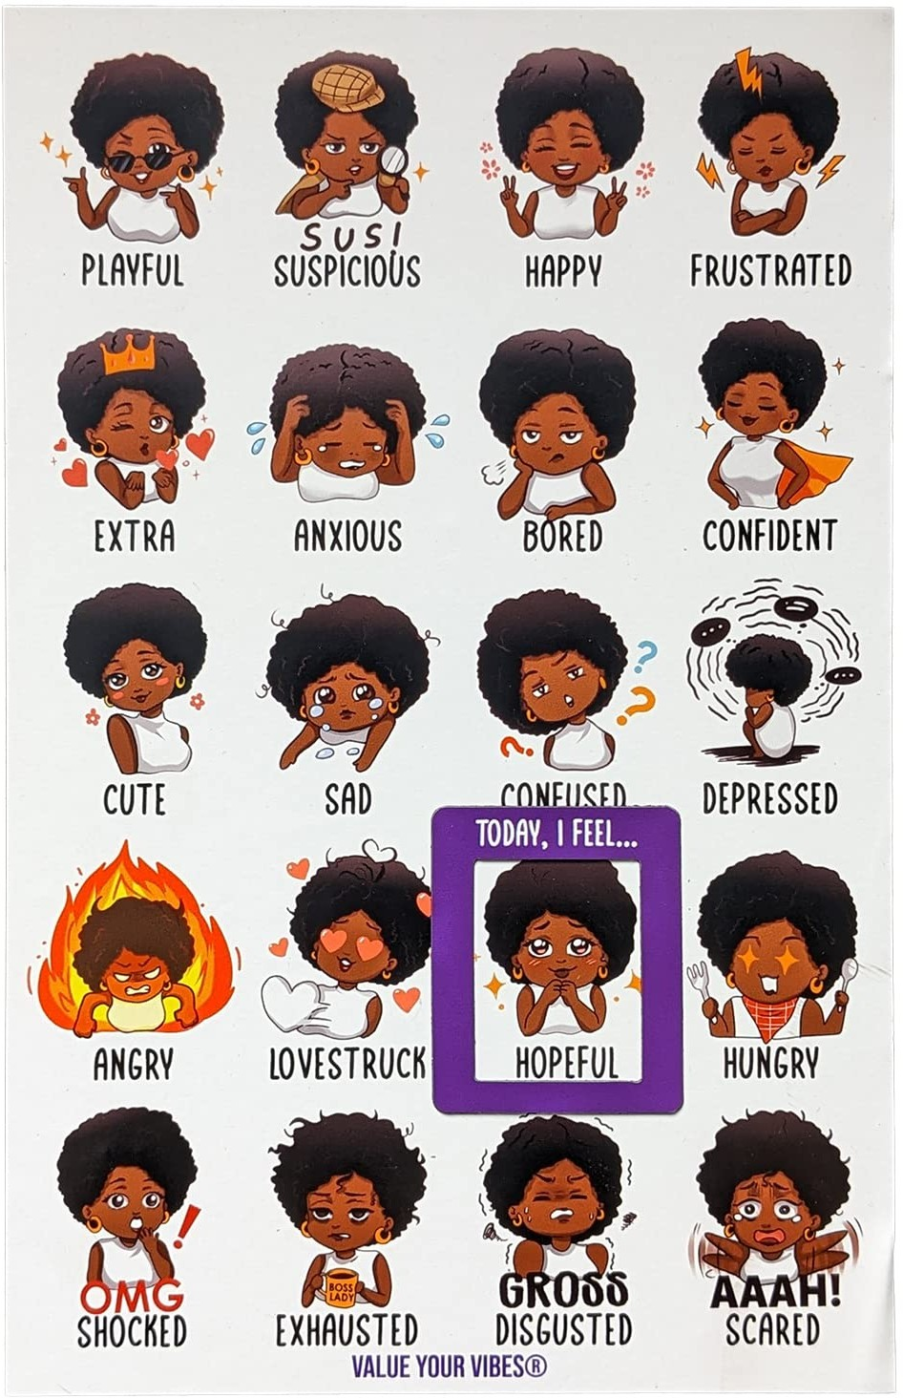

**Sample Role Model Biographies\***

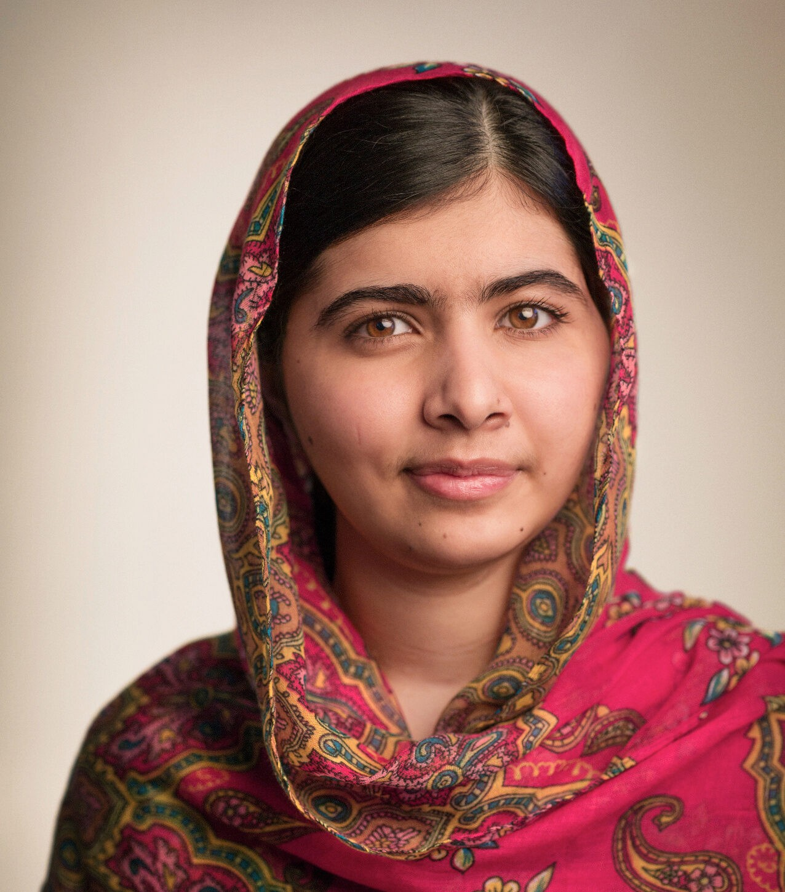***Malala Yousafzai*** *is a smart and brave young woman from Pakistan. When she was a young girl, she loved going to school and learning new things. But some people didn't want girls to go to school. They tried to stop Malala, but she spoke out for the right of all girls to get an education. In 2012, when she was 15 years old, she was hurt very badly by some people who didn't want her to speak out.*

*Malala and her family had to leave their home and become refugees, moving to another country to be safe. But she got better and continued to be a strong voice for girls' education around the world. In 2014, she became the youngest person ever to win the Nobel Peace Prize. Now, she travels to many countries, helping girls go to school and follow their dreams.*

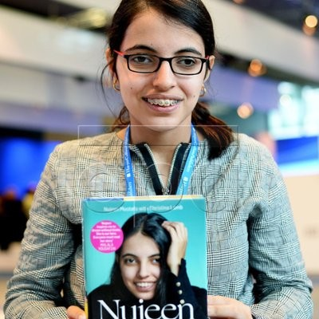***Nujeen Mustafa*** *is a brave and inspiring young woman from Syria. She was born with cerebral palsy, which means she uses a wheelchair to get around. When war started in her country, Nujeen and her family had to leave their home to ﬁnd safety. Nujeen traveled over 3,500 miles to Europe, all while sitting in her wheelchair, with the help of her sister. She faced many dangers and challenges along the way but never gave up. Now, she speaks out for the rights of refugees and people with disabilities, sharing her story to help others. Nujeen wants to make sure everyone has a chance to live a safe and happy life, no matter where they come from or what challenges they face.*

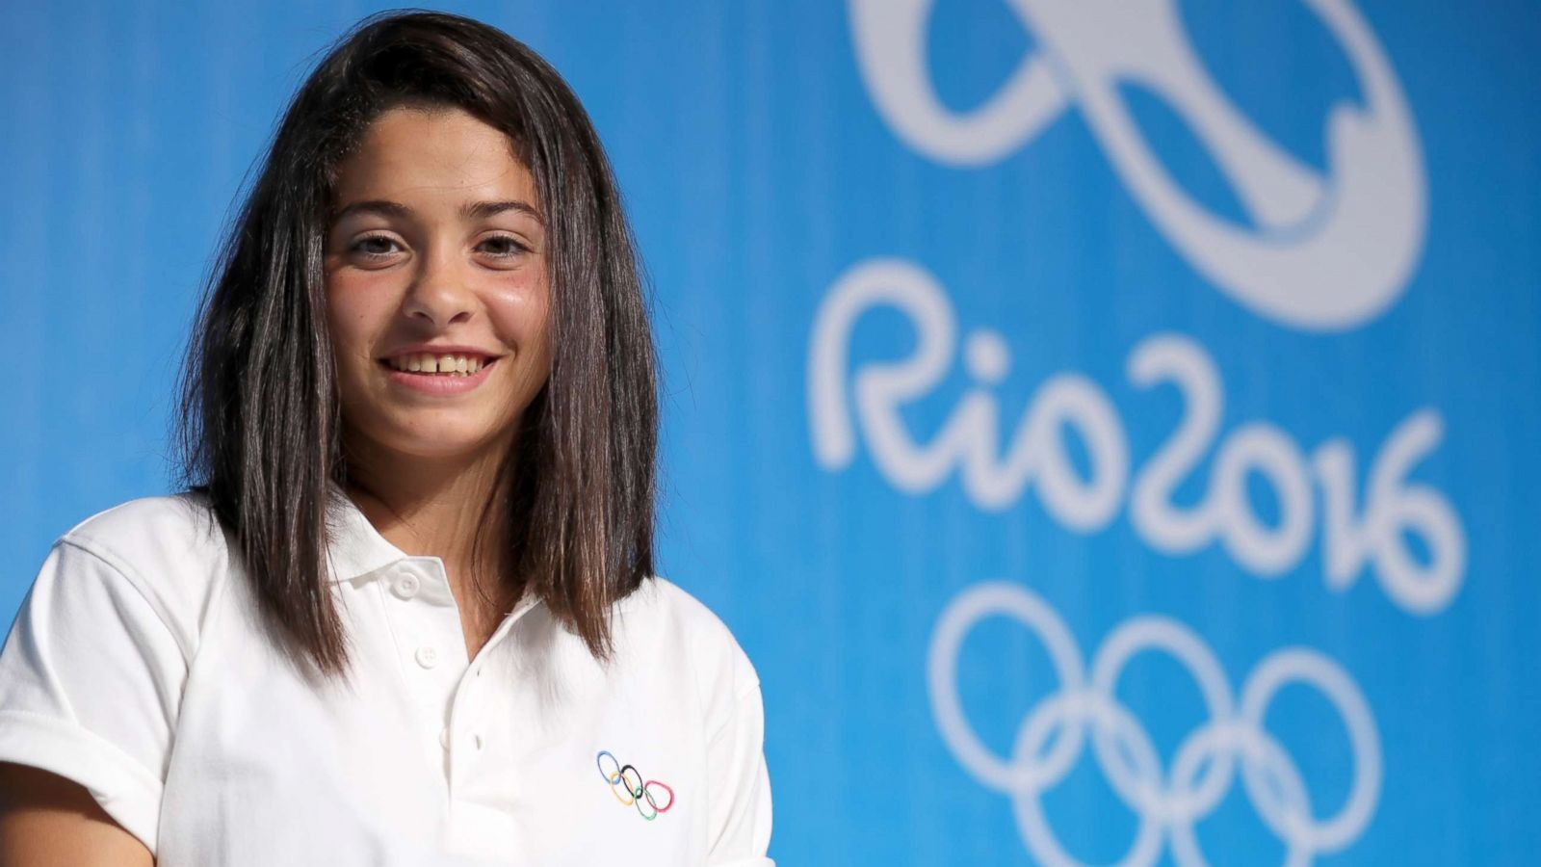***Yusra Mardini*** *is a strong and inspiring young woman from Syria. She loved swimming and trained hard to become a strong swimmer. When war started in her country, Yusra and her sister had to leave their home to ﬁnd safety. During their journey across the sea, their boat started sinking. Yusra and her sister jumped into the water and, with a few others, swam for hours, pushing the boat to shore and saving everyone on board. After reaching safety in Germany, Yusra kept swimming and trained even harder. She competed in*

*the 2016 and 2020 Olympics as part of the Refugee Olympic Team. Now, she helps other refugees and shares her story to inspire people around the world to never give up on their dreams.*

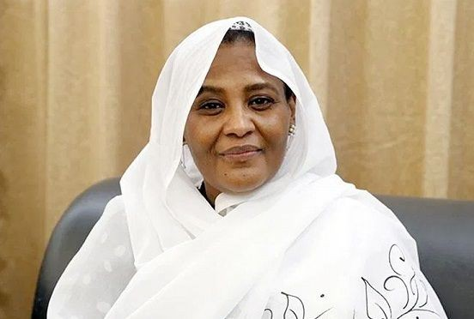***Mariam Al-Mahdi*** *is an important leader from Sudan who works hard to help her country and its people. When she was young, her family had to leave Sudan and live as refugees in Egypt because of political problems. Despite the challenges, Mariam studied to become a doctor and later became involved in politics. She became the ﬁrst woman to be Sudan's Minister of Foreign Affairs in 2021. This means she helps Sudan talk to other countries and make important decisions. Mariam is known for her strong voice and efforts*

*to bring peace and fairness to her country. She works to ensure that everyone in Sudan can live in a safe and just society. Mariam inspires many people, especially girls, to follow their dreams and make a difference in the world.*

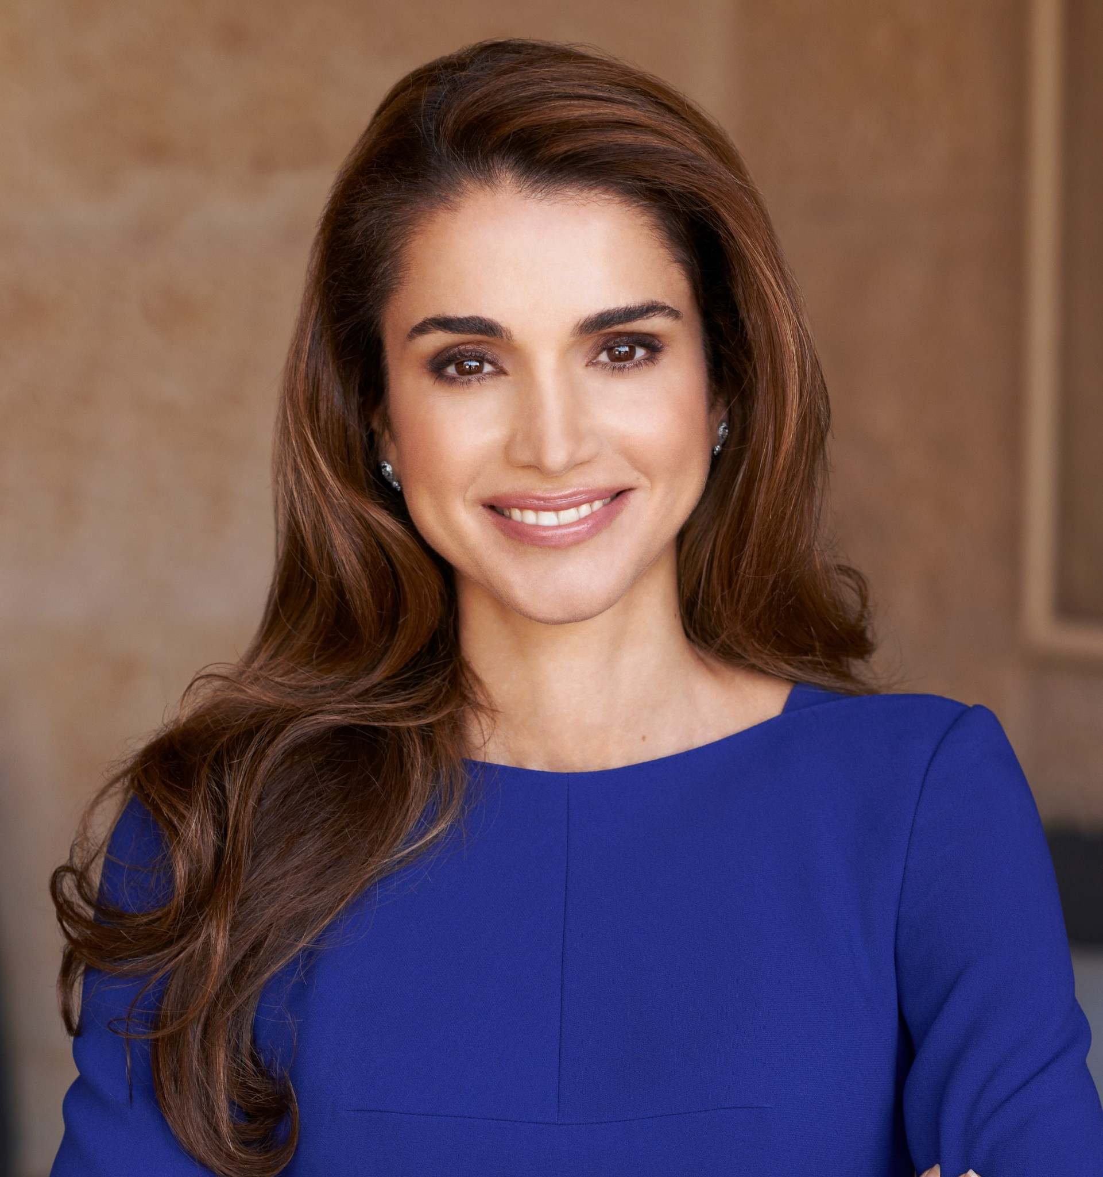***Queen Rania of Jordan*** *is a kind and inspiring leader. She was born in Kuwait, but her family had to ﬂee to Jordan. In 1993, she married King Abdullah II and became Queen of Jordan. Queen Rania works hard to help people in her country, especially children and women. She has started many programs to improve education and health care in Jordan - a country that has welcomed many people who had to leave their homes because of war. She works to make sure they*

*have food, shelter, and education. Queen Rania loves to connect with people and share her ideas, and she inspires many people around the world to make a positive difference.*

**\*Please note** that sample role model biographies were generated by ChatGPT and have not been fact-checked.