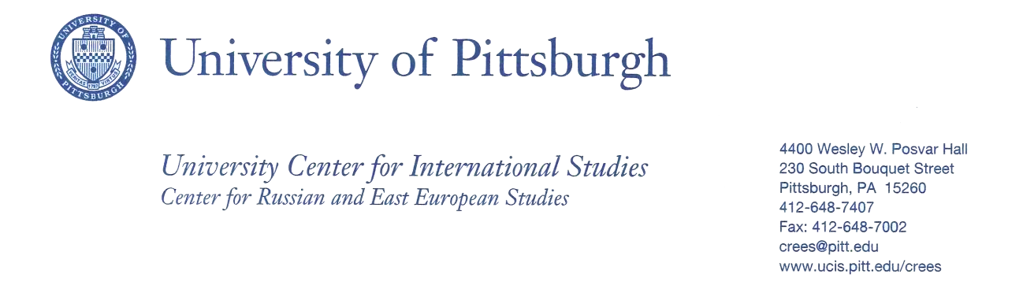

The United States and the Eastern Bloc in the 1960s

Tyler Mannion, Adjunct Faculty, History
Community College of Beaver County

Course Title
HIST 218: The 60s

Course Description
Students will survey American history from 1955 to 1974, a period that deals with the disaffection experienced by the young as a result of their frustration with politics, society, and the war in Vietnam.

Course Objectives
Upon completion of this course, students will be able to:

- Appraise the significance of the 1960s upon current conditions.
- Distinguish between primary and secondary sources of historical writing.
- Understand the differences between two schools of historical thought.
- Draw valid conclusions about the 1960s.

Lesson Module Title
The United States and the Eastern Bloc in the 1960s.

Module Objectives
Upon completion of this module, students will be able to:
- Understand the how and why of the Cold War
- Experience the Cold War as a global phenomenon
- Draw conclusions of the Cold War as viewed via popular culture of the time
- Gain a greater perspective of what those living under communism experienced
- Tackle orientalism and its application to the Eastern Bloc

Module Overview
This course module will be implemented in the fall of 2016 and will be a focus of the course for several weeks. Typically, this course has met two days a week for an hour and twenty five minutes for each session. Topics to be covered will include background information of the Cold War as well as depictions of this era in popular culture. In particular, I will be showing the 1964 Cold War classic Doctor Strangelove: Or How I Learned to Stop Worrying and Love the Bomb. I believe that this film is important as it is not only a classic in terms of American film history, but paints an

incredible portrait of nuclear hysteria during the height of the Cold War and while that event was still unfolding.

Another significant focus of this module will be tackling the concept of orientalism and how it has affected the perspective and how they viewed ordinary citizens who were living under communist rule in the Eastern Bloc. Examples of orientalist depictions I will show in class in order to facilitate discussion include the following links:

Wendy’s 1980s commercial “Soviet Fashion Show”
https://www.youtube.com/watch?v=5CaMUfxVJVQ

The Simpsons “Crazy Vaclav’s Place of Automobiles”
https://www.youtube.com/watch?v=07vdtBMG4Kg

As part of the orientalism portion of the module, students will also read the article Nesting
Orientalisms: The Case of Former Yugoslavia by Milica Bakić-Hayden

My experiences as a result of participating in the Bridging Cultures program has significantly affected the route I have decided to take with this course module. Not only did it encourage me to focus on concepts such as orientalism, but due to the involvement of University of Pittsburgh faculty, I have decided to place a greater emphasis on the experience of Yugoslavia during the Cold War period. One such example of this is the use of the aforementioned article Nesting Orientalisms. This is as a direct result of participating in this project. Without this program, I surely would have solely focused on just the United States and the Soviet Union and their direct relationship.

Key Terms
Language will be a key component of this learning module as the Cold War would eventually develop its own culture and jargon. In addition to the aforementioned focus of orientalism, significant emphasis will be placed on Cold War concepts such as Mutually Assured Destruction (MAD), Proxy Wars, NATO and Warsaw Pact, in addition to other key terms that are paramount in understanding this period in history.

