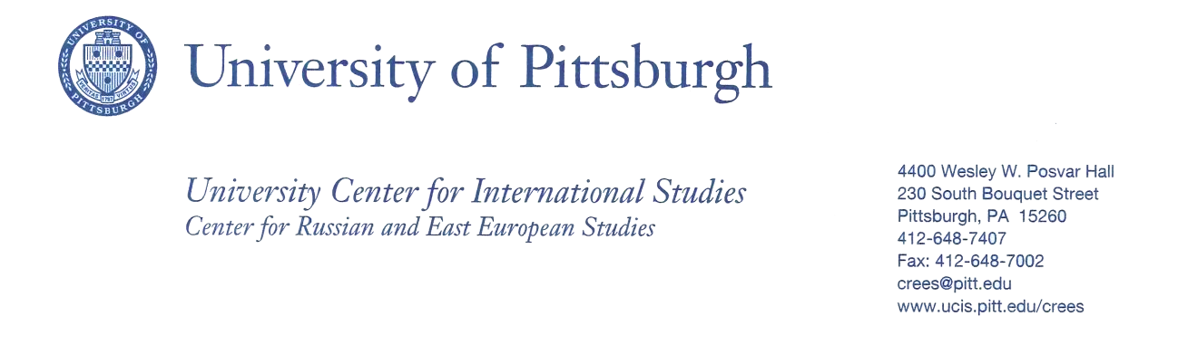
Dr. Cynthia L. Marshall
Liberal Arts Division
Community College of Beaver County
Course: Cinema as Art, FILM 101

Eastern European Course Module
East Central Europe Films

Course Description
Cinema as Art is a current class offered at The Community College of Beaver County. In Cinema as Art, students explore film as an art form. Included are explanations of film production, film genres, themes, trends, and transitions. The course presents fundamentals of critical responses to viewing films as a medium of communication past and present.

East/Central Europe Course Module Description
The Cinema Class is going to highlight East Central Europe films and film directors during the 2015-2016 and 2016 –2017 semesters. The initial syllabus will be followed in terms of genre film discussions and note taking of cinematic values of the films.

Learning Objectives for Cinema as Art: East Central Europe Films
The Student will be able to
- Read biographies of contemporary film directors of East Central Europe and identify and analyze their particular auteur styles.
- Compare governance policies/dicta/censorship as portrayed in East Central European films to films produced in the United States. These policies may include communism, socialism, and fascism, currently and historically.
- Recognize and identify original and creative cinematic techniques which are introduced in East Central European films, including elements of editing, cinematography, and acting.
- Define and Discuss polemical elements in East Central European films.
- Use the thematic constant of “the human heart in conflict with itself” as a template to analyze critically East Central European films.
The East Central Europe films will correlate with the genre theory of the course.

Films Assigned to Students

These films may include, but are not exclusive to the following:
Stalker (1979), Andrei Tarkovsky, Russia
Genre: Science fiction, existential existence, art film
Ida (2013), Pawel Pawlikowski, Poland
Genre: Woman’s search for identity, War connections
The Fireman’s Ball (1967), Milos Foreman, Czechoslovakia
Genre: Political Comedy, satire
Kolya (1997), Jan Sverak, Czechoslovakia
Genre: Political History: Russian occupation film ending in Berlin Wall dropping
The Unbearable Lightness of Being (1988), Philip Kaufman, Czechoslovakia – USA
Genre: Romance
Europa, Europa (1990), Agnieszka Holland, Poland
Genre: War romance/adventure
Knife in the Water (1962), Roman Polanski, Poland
Genre: Suspense. Definitive Polanski

Evaluation of students
The students will be required to write film notes for each film; these notes are based upon the ability to discern cinematic techniques and student research on the film’s production and direction. Also, the students will be required to participate in critical film discussions that analyze the cinematic aspects of each film. Students also participate in group work using specific film work sheets that the professor creates. For example, Tarkovsky’s film will require students to debate the science fiction genre of Russian films compared to American films.

Benefits of participation in Bridging Cultures grant-funded Course
The Bridging Cultures project has helped Dr. Marshall create this module in the following ways. The project has
- Created a historical focus to understand the forces which have shaped East Central European art and cinema
- Supplied and explained historical and contemporary literature to aid in the understanding of East Central European philosophical thought and political thought.
- Offered advice in terms of curriculum development.
- Answered questions and held open discussion concerning the biases that Americans may hold in terms of East Central European society and governance.
- Enriched the faculty’s foundation of knowledge to include what, at first, seemed to be an elusive area of world culture and mapping.

***See Lesson Plan and Student Worksheet Below

Lesson Plan to Incorporate East European film in Cinema as Art Course
Objectives:
- To follow Cinema as Art Syllabus which indicates that it is genre film study.
- To provide students with East Europe directors, films, and stories in specific genre study.

Roman Polanski, innovative director, troubled soul
- Polanski biography (highlights) including Jewish orphan found on streets of Warsaw after WWII, husband of Sharon Tate, unresolved criminal record in United States, genius, and Academy Award Winner.
- Introduction to Knife in the Water, as new wave - suspense but also as allegory. Status Quo brings in new element, which is exciting, but realizes that the danger is real and unstoppable.
- Knife in the Water is historically important, but also precursor to Polanski films: evil is lurking, normal people caught up in abnormal horror-must step up to the plate, evil is alluring, sexual, darkly charismatic.
- Cinematography: light shimmering on yacht, complacency of wealth, evil can be in brilliant sun, wind/nature not controllable.
- Polanski as auteur: , Carnage Tess, Fearless Vampire Killers
- Discussion: the artist as cautionary example vs. the artist’s creativity

Milos Forman, American Czech productions
- Forman as wry comedian, satirist, academy award director, short bio.
- Melding Czech and American influences including dark humor: Amadeus, One Flew Over the Cuckoo’s.
- Fireman’s Ball: film of bureaucratic absurdity (the light side of bureaucracy as One Flew Over the Cuckoo’s Nest is dark side).
- The use of color cinematography as creating mood and tonal quality in film.
- Discussion: Regime and political criticism masked as humor. Is it valid?

Andrei Tarkovsky, Russian
- Tarkovsky as artistically innovative, mixing magical realism and harsh realities, short bio
- Thematic director: mind over body, non-linear plot, long takes, metaphysical themes, dream imagery, switches color/black and white
- The mind as something that can never fully be trusted: restless and inner eye shots
- Stalker: beautiful imagery, but reality is a ZONE.
- Discussion of existential ideals, imprisonment of minds, and creativity in nothingness: what do you do when the film is more intellectually challenging rather than entertaining?

Kristov Kieslowski, Polish
- Kieslowski as polemicist, short bio.
- A short film about Killing: anti capital punishment, even though the killing is horrific. Violence as plot conveyance and political conveyance.
- The concept of verisimilitude in Kieslowski’s films
- Discussion: Is Kieslowski perhaps the best film director? Why or why not? American directors perhaps overrated?

Agnieska Holland, Polish
- Holland as crossover: Polish to American cinema
- Europa, Europa: using history to define future
- Warm human drama while enduring a reign of terror
- Character studies in Holland films: the distant father/family, the young person trying to create sense out of madness, youth trying to fit in, Jewish identity, nature as soothing, life moving on and accepting sadness as part of life.
- Discussion: Are female East Europe directors taken more seriously as auteurs than American female directors? Why might this be?

QUESTIONS FOR STUDENT RESPONSE TO FILMS

Things to think about and write about while watching the film.

- How does the film get across symbol and metaphor to you cinematically? (a face half shadowed is someone not telling all the truth)
- Who is the director? What can you find out about him/her?
- Who tells the film’s story? Many people? One person? An omniscient presence?
- What is the basic plot? (This should take two-three sentences at most).
- What am I feeling while watching the film? What is the atmosphere of the film? Foreboding? Happiness? How does the film tell me cinematically these things?
- Do I sympathize with any one character? Do I feel distrust, trust, or do I dislike a particular character? Do I feel that someone is wrong in the role or right in the role?
- Do I care about the characters? Why? Why not?
- Do any of the characters change?
- Do they have conflict of the human heart within itself?
- Are there moments or dialogue which I thought were: Humorous? Sensitive? Passionate? Enraging? Thought Provoking? What were these lines?
- Why did the director decide to tell this story?
- What are my questions?
- What new ideas have I formed?
- What elements listed below embody the film?
  - Sociological
  - Religious
  - Historical
  - Psychological
  - Educational
  - Philosophical
  - Process
  - Book
  - Graphic novel
  - GAME
  - An idea
  - Television show
  - Character Concept
  - Title
  - A treatment
  - The purchaser: control over players/placed in storage/studio control
  - Screenplay: book-author/screenplay/writer/direct/actor/studio
  - Changes to treatment: different ending/romantic entanglement/romantic lead/older/younger
  - Director/actor/producer/executive
  - Auteur/author
  - Studio/independent film making
  - Studio agreement with auteur
  - Union/non-union IATSE
  - Storyboard/cinematographer/locations/sets/producer’s role/non chronological filming/actors’ schedules/physical conditions/weather acts of god/ (digital) aperture of camera/on line sales/Netflix/ cost of special effects/cge/cgi/
  - Lighting, electricians, sound, cameras
  - Overdubbing for television/foreign/international markets editor
  - Music
  - Changes: $ / length of film/timing of release/title/distribution/A cities/
  - Sleepers
  - Two/three movie deals
  - sure things/entertainment/art/audience interest

