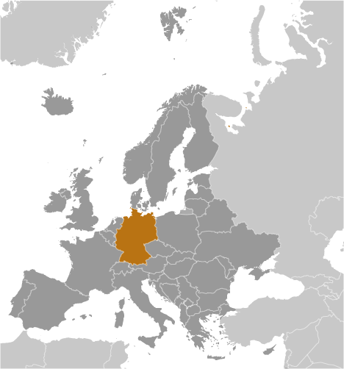
The Federal Republic of Germany
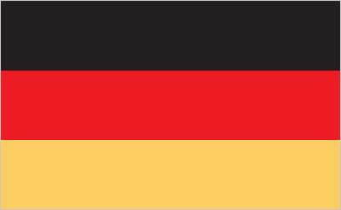
Founding Member of EU (1958)
- Europe’s largest economy
- Europe’s second most populous nation
- Germany population makes up 16% of the total EU population.
- Germany has 96 members of the EU‘s Parliament. (There are 751 members in total.)
- Germany is a key member of the continent’s economic, political, and military organizations.
- Germany was devastated by both World Wars.
- Germany is very responsible with their money. They don’t believe in spending more than they make, as they had many economic problems stemming from the war period.
- Afterword, it was occupied by the US, UK, France, and the Soviet Union.
- The fall of communism allowed Germany to reunite in 1990. Since then, Germany has spent a great deal of money modernizing and raising the standard of living there.
- Germany was able to rebuild thanks to loans from other countries, notably the United States. So they believe in cooperation between nations.
- Germany is 3x the size of Pennsylvania.
- Germany has an educated but aging population (3rd oldest in the world).
- Head of Government: Chancellor Angela Merkel (since 22 November 2005)
- Refugees and internally displaced persons:
  - 41,167 (Iraq)
  - 40,994 (Syria)
  - 27,814 (Afghanistan)
  - 22,242 (Turkey)
  - 18,814 (Iran)
  - 9,294 (Serbia and Kosovo)
  - stateless persons: 12,569 (as of 2014-2015)
- Germany’s main export partners are France, the US and the UK while its main import partners are the Netherlands, France and China.
All facts and graphics taken from https://europa.eu/european-union/about-eu/countries/member-countries/germany_en#practical-information and https://www.cia.gov/library/publications/the-world-factbook/geos/gm.html .
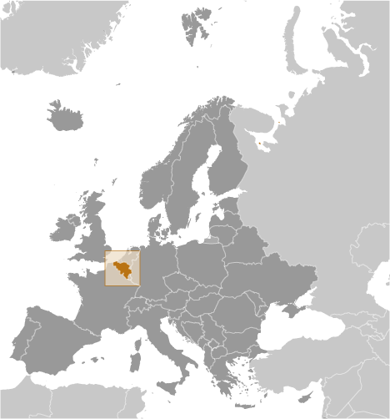
The Kingdom of Belgium
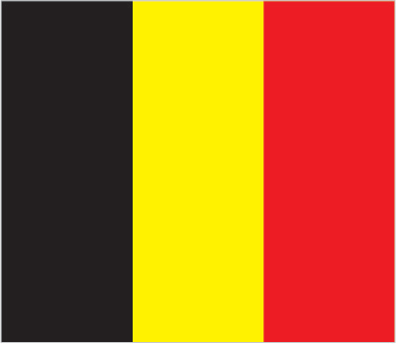
Founding Member of EU (1958)

- Belgium became independent from the Netherlands in 1830.
- It was occupied by Germany during World Wars I and II.
- A nation with a modern, technologically advanced economy
- But, they also carry a lot of debt.
- Its capital city, Brussels, is home to many EU institutions and NATO. These institutions are very popular in the country because having all of those visitors brings in money to their economy.
- Though they have a ceremonial king, their Head of Government is Prime Minister Charles Michel (since 11 October 2014)
- Belgium’s population is only 2.2% of the EU’s total population.
- They only have 21 representatives to the EU Parliament (out of 751 in total).
- Belgium is approximately the size of Maryland.
- Refugees and internally displaced persons:
  - 5,038 (Afghanistan) (2014)
  - stateless persons: 5,776 (2015)
- Belgium’s main export partners are Germany, France and the Netherlands while its main import partners are the Netherlands, Germany and France.

All facts and graphics taken from https://europa.eu/european-union/about-eu/countries/member-countries/belgium_en and https://www.cia.gov/library/publications/the-world-factbook/geos/be.html .

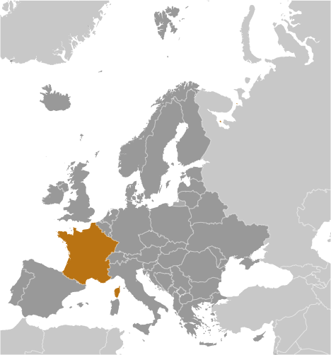
French Republic
Founding Member of EU (1958)
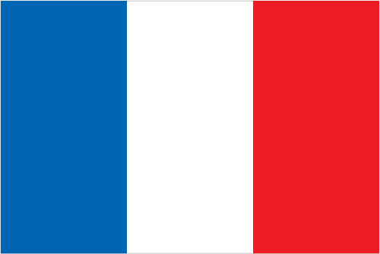

- France today is one of the most modern countries in the world.
- They are leaders among European nations—being permanent member of the United Nations Security Council, NATO, and the EU.
- In recent decades they have become close allies with Germany, working to make Europe’s economy stronger.
- Despite being a rich nation, the economic troubles of the last decade have been hard on France. They have a growing debt problem. And almost 1 out of every 4 young Frenchmen is unemployed.
- France is a nation that thinks it is very important to separate religion and government.
- France has experienced a wave of terrorist violence—primarily by Muslim extremists--over the last three years.
- They have both a President and Prime Minister, but the figure that represents them at the EU is their Head of Government, President Francois Hollande. (since 15 May 2012)
- Tourism is huge in France. It is the most visited country in the world.
- Belgium’s population is 13.1% of the EU’s total population.
- They have 74 representatives to the EU Parliament (out of 751 in total).
- France is slightly smaller than Texas, making it the largest western European nation in terms of land area.
- Refugees and internally displaced persons:
  - 23,966 (Sri Lanka)
  - 13,727 (Democratic Republic of the Congo)
  - 13,644 (Russia)
  - 12,003 (Cambodia)
  - 12,119 (Serbia and Kosovo)
  - 10,699 (Turkey)
  - 8,281 (Vietnam)
  - 7,036 (Laos)
  - 5,201 (Guinea)
  - 5,058 (Mauritania)
  - stateless persons: 1,326 (2015)
- France’s main export and import partners are Germany, Belgium and Italy.

All facts and graphics taken from https://europa.eu/european-union/about-eu/countries/member-countries/france_en and https://www.cia.gov/library/publications/the-world-factbook/geos/fr.html .
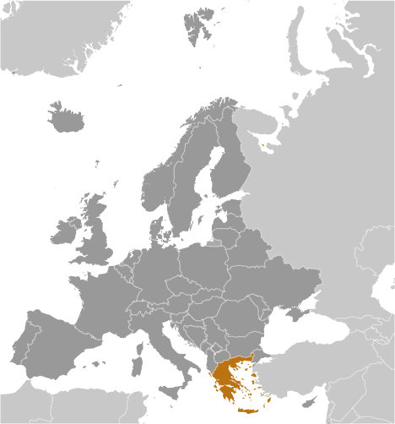
Hellenic Republic (Greece)
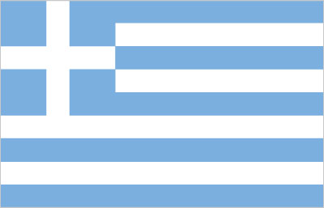
Joined the EU in 1981

- Greece achieved independence from the Ottoman Empire in 1830.
- Greece has been in economic crisis since 2009. Over 25% of people are unemployed (a number even high among the young) and over 1/3 of the population is in poverty.
- Many people come to see the natural beauty of the Greek islands and enjoy its Mediterranean climate. So, tourism is important to the Greek economy.
- They have both a President and Prime Minister, but the figure that represents them at the EU is their Head of Government, Prime Minister Alexis Tsipras (since 21 September 2015).
- Greece’s population is actually shrinking. (Less people are being born than are dying.)
- Greece’s population is only 2.1 % of the EU’s.
- They only have 21 representatives to the EU Parliament (out of 751 in total).
- Greece is slightly smaller than Alabama.
- Refugees and internally displaced persons:
  - 1,017,669 estimated refugee and migrant arrivals by sea (2015 - June 2016)
  - This has greatly increased because of the Syrian Civil War (which is very close to them).
- Greece is a gateway to Europe for traffickers smuggling drugs from the Middle East and Southwest Asia to Europe.
- Greece’s main export partners are Turkey, Italy and Germany while its main import partners are Russia, Germany and Iraq.

All facts and graphics taken from https://europa.eu/european-union/about-eu/countries/member-countries/greece_en and https://www.cia.gov/library/publications/the-world-factbook/geos/gr.html .

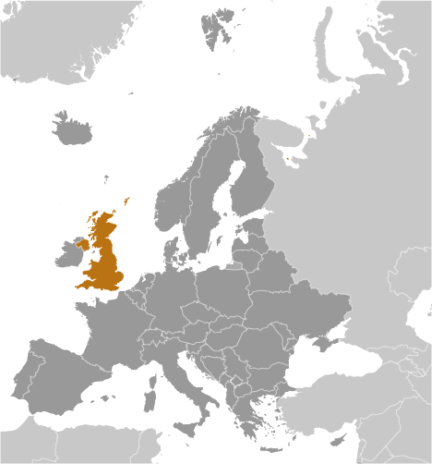
The United Kingdom of Great Britain (inc. England, Scotland, and Wales) & Northern Ireland
Joined the EU in 1973
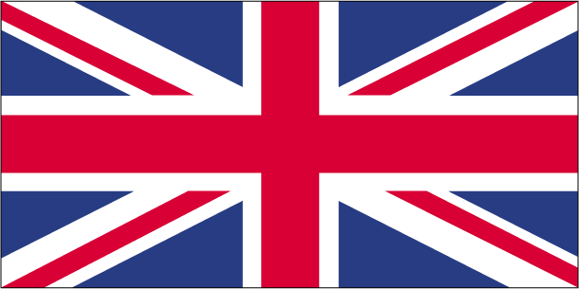
- Up until the 19th century, The United Kingdom maintained an empire that stretched over one-fourth of the earth's surface.
- But the two world wars in the 20th century left the UK depleted.
- It has rebuilt itself into a modern and prosperous European nation.
- The UK, a leading trading power and financial center, is the third largest economy in Europe after Germany and France.
- London is the major banking center of Europe.
- They have both a Queen and Prime Minister, but the figure that represents them at the EU is their Head of Government, Prime Minister Theresa May (since 13 July 2016).
- Greece’s population is 12.8 % of the EU’s.
- They have 73 representatives to the EU Parliament (out of 751 in total).
- The UK is twice the size of Pennsylvania.
- The UK has a significant immigration rate. They are in the top 20% of nations worldwide in terms of people moving there from abroad.
- Refugees and internally displaced persons:
  - 11,583 (Eritrea)
  - 11,510 (Iran)
  - 9,467 (Zimbabwe)
  - 9,039 (Afghanistan)
  - 8,509 (Somalia)
  - 5,669 (Pakistan)
  - Stateless persons: 41 (2015)
- The UK’s main export partners are Germany, the US and the Netherlands, while its main import partners are Germany, China and USA.
All facts and graphics taken from https://europa.eu/european-union/about-eu/countries/member-countries/unitedkingdom_en and https://www.cia.gov/library/publications/the-world-factbook/geos/uk.html .

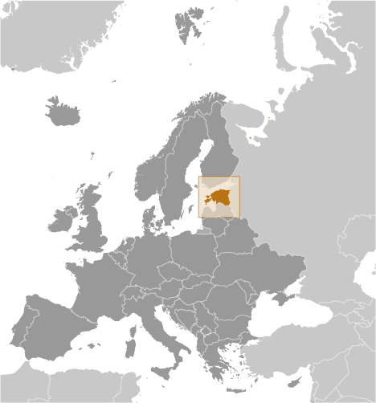
The Republic of Estonia
- Joined the EU in 2004
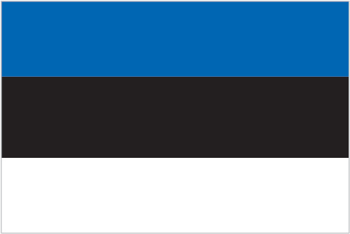

- After centuries of Danish, Swedish, German, and Russian rule, Estonia attained independence in 1918.
- Russia forced them to be a part of the Soviet Union in 1940 and they were not free again until 1991 (with the fall of the Soviet Union).
- Russia’s recent aggression is a major concern for Estonia.
- Estonia has built economic and political relationships with Europe and America since then.
- They have a modern economy that is one of the strongest in Central or Eastern Europe.
- They have a low national debt and a balanced budget.
- They are actually having more people emigrate (leave the country) than immigrate (enter the country) every year, so they are in need of workers.
- Estonia is an electronics and telecommunications power in Europe.
- They have both a President and Prime Minister, but the figure that represents them at the EU is their Head of Government, Prime Minister Taavi Roivas (since 26 March 2014).
- Greece’s population is only 0.3 % of the EU’s.
- They only have 6 representatives to the EU Parliament (out of 751 in total). They are tied with 3 other nations for the smallest delegation to the EU.
- Estonia is about twice the size of New Jersey.
- Refugees and internally displaced persons:
  - stateless persons: 85,301 (2015)
- Estonia’s main export partners are Sweden, Finland and Latvia, while its main import partners are Finland, Germany and Sweden.
All facts and graphics taken from https://europa.eu/european-union/about-eu/countries/member-countries/estonia_en#estonia-in-the-eu and https://www.cia.gov/library/publications/the-world-factbook/geos/en.html .

Getting Started
Tomorrow we start our simulation of the European Union! To help you get you into character and get ready to take part, try to learn more about your nation.
One great site to do that is:
- http://www.ifitweremyhome.com/
- When you go there, click on “Country Comparison” (in the upper right hand corner).
- On this page you can compare your country to the United States in many different ways. (Don’t forget to click on the down arrows (at the right of each fact bar) to get more information.)
- You can also compare your country to others in our simulation. In case you don’t remember, the following countries will be participating:
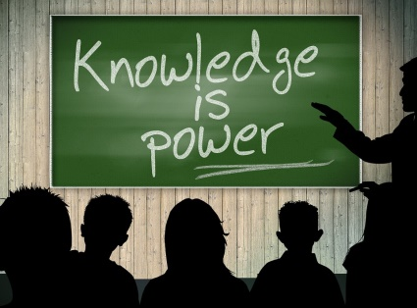
  - Estonia
  - The United Kingdom
  - France
  - Belgium
  - Greece
  - Germany

Remember, knowledge will be power! So learn all that you can about your nation, and your fellow Europeans. (And don’t get upset if you don’t know something. We’re doing this to learn. ;D)

