May 8, 1945: Peace in Europe
But, for how long?

Allied victory in Europe was declared on May 8th, 1945, after nearly six years of bloody conflict. Germany was completely defeated.
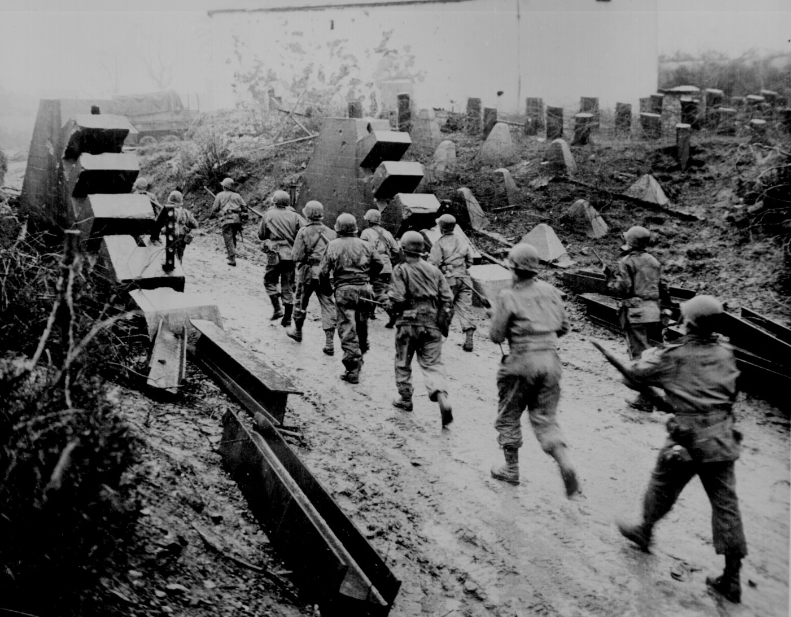
Only thirty years had passed between the start of the First World War and the end of the Second World War. Both wars were caused by conflicts between European neighbors. These were some of the riches countries in the world and yet they sought to destroy each other. Germany invaded France twice in 26 years, each time also invading Belgium, the Netherlands and Luxembourg. The wars got so big that Great Britain and Russia were pulled into the conflict, too. They eventually became true world wars with fighting around the globe including—Asia, Africa, the Pacific, etc.
World War I was horrific, and World War II was more brutal, and bloodier than anyone who survived the Great War could have imagined. The Second World War caused the deaths of around 60 million soldiers and civilians. (To quantify that number for you, if the US lost 60 million people today, that would mean that roughly 1 out of every 5 people would perish!)
To make matters worse, the systematic genocide of the Holocaust killed over 6 million people (primarily Jews) In addition, many cities, towns and villages across Europe were completely destroyed by aerial bombing and heavy artillery. Thousands of Europeans became refugees and displaced persons. Almost everyone in Europe was affected by the war.
A common expression after 1945 was “Never again,” which symbolized a universal hope to avoid another world war. The peoples of Europe were especially committed to this ideal after watching their families torn apart and their homes destroyed.
But how could peace in Europe be guaranteed? Many felt nationalism—or feeling that your own country is superior to others—was responsible for the wars. The great powers in Europe, the United Kingdom, France, Germany, and Russia competed fiercely with each other. Even in peacetime they competed to be the wealthiest or to have the strongest military.

Keeping all of this in mind, how might we prevent the next world war?

This article has been adapted for middle school use from Canada’s Carleton University. The full text can be found at: http://carleton.ca/ces/eulearning/history/europe-after-wwii/
The Solution:
For many people, the answer became clear: Europe must be integrated. Instead of competition between European states, there was a need for a system of co-operation.
But there were many obstacles and difficulties they had to overcome to achieve this goal. You will get to experience these challenges first hand during the coming week.

Your Challenge: Should you choose to accept it…
- We are going to try and prevent Europe from descending into another war, by uniting to form a European Union!
- Our EU will be faced with the simulations of the real challenges that Europe has faced. You will need to use your intellect and people-skills to find solutions that many people can agree upon.

- Each social studies class will be assigned a country. Yours will be: ______________________
- Tonight, you have two jobs:
  - Become familiar with your new nationality by reading your nationality sheet (and going to the websites on it, if you are able). Feel free to write down questions or comments on this and all other sheets, as it will help you during our simulation.
  - Then, read the Proposal #1 on the Schengen Area. Answer the questions and prepare to come in tomorrow and save Europe!

Captain Euro Image Credit: http://www.captaineuro.eu/characters/

